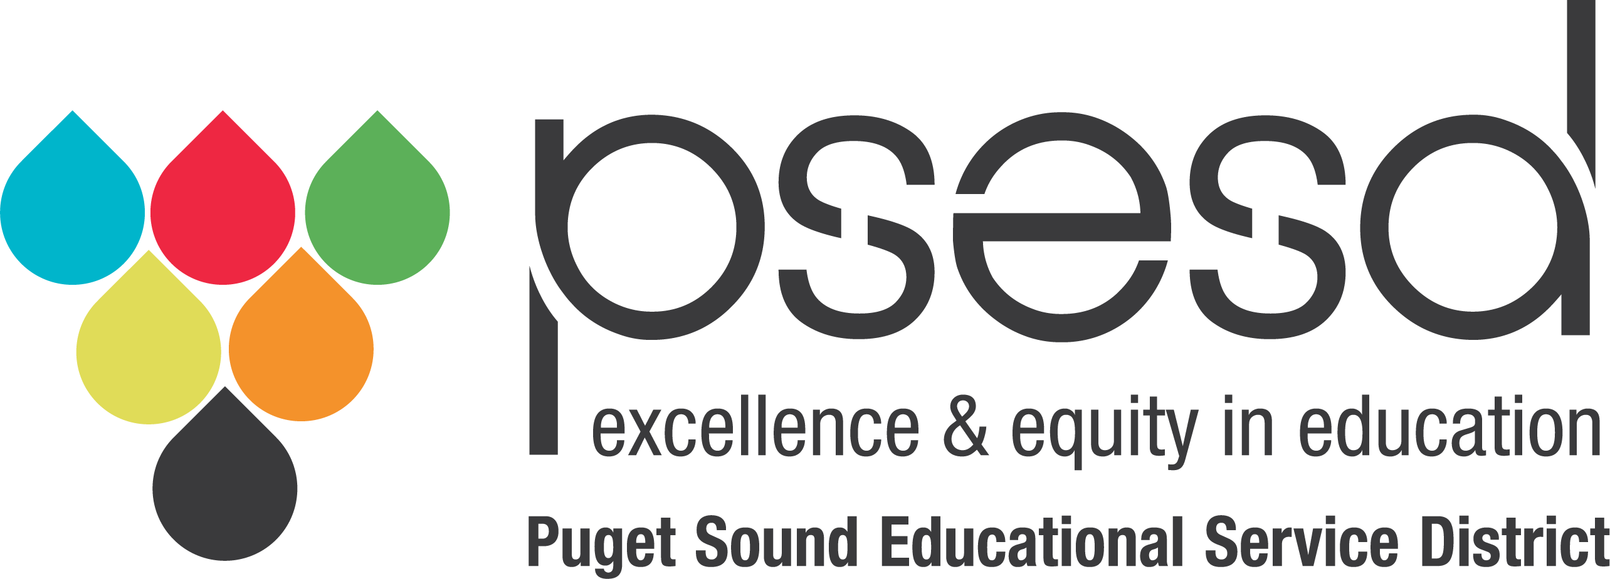

Join Our Board!

Puget Sound Educational Service District is seeking a diverse group of representatives to consider becoming members of the agency's Board of Directors.

- Ensure agency achieves its End: Success for Each Child and Eliminate the Opportunity Gap by Leading with Racial Equity
- Set agency direction through monthly board meetings
- Approve financials and policies
- Build networks and partnerships
- Embodies the PSESD competencies of cultural proficiency, racial equity advocacy, racial equity mindset, and living into transformational values

Please visit our website www.psesd.org for more information.

Applications due by September 16

