Community Prevention & Wellness Initiative

Partners for Healthy Communities

Bethel Community Services

Bethel, WA

Coalition Vision Bethel Community Services exists to support the Bethel
community by networking resources to educate, empower, and create new opportunities for youth and families.

Coalition Mission
To address the need of our most at-risk families at the Bethel Family Center, to network and provide services for homeless youth, to prevent and reduce substance abuse among youth, to promote attendance, achievement, and success at school and in the community.

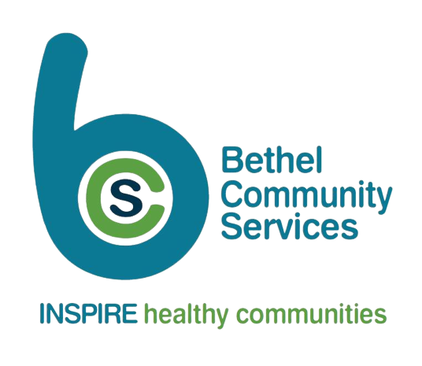

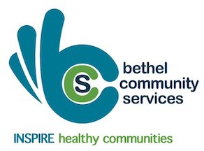
About the Community Prevention and Wellness Initiative (CPWI)
CPWI is a partnership of state agencies, counties, schools, and local prevention coalitions supporting communities in preventing alcohol and other drug abuse and its negative consequences. CPWI priorities include reducing underage drinking, marijuana use, and opioid misuse/abuse among middle and high school aged youth. By providing evidence-based practices and promoting the positive changes in communities, we can build healthier communities.

About the Coalition: Communities & Schools Working Together
The INSPIRE substance use prevention workgroup was formed in 2017. We are a partner coalition of the Bethel Community Services (BCS) coalition, a non-profit agency. BCS has been in existence since 2001 and has a long-standing history and great reputation in the Spanaway/Bethel Community. INSPIRE is focused in the Cedarcrest Middle School and is collaborating with district staff throughout Bethel Schools.
Locally, our highest priority is to reduce vaping and cannabis use among Bethel students. Our youth voice is important and has been elevated by creating our youth subcommittee on our coalition which was created, and is led by youth from our district and community.

Some of the partnerships that have helped with the development and subsequent success of the BCS and INSPIRE work group include: Bethel School District, Bethel Family Center, Pierce County, Community Health Care, Consejo Counseling and Referral Services, Molina Healthcare, National Military Family Association, Safe Street, and Tacoma Pierce County Health Department. More partnerships will be developed and solidified to help implement substance use prevention activities.

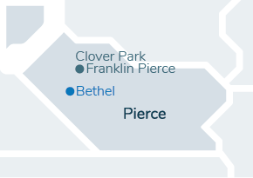

About Our Community
The Bethel School District is a rural community that encompasses 202 square miles in Pierce County. There are approximately 20,000 enrolled students with 53% qualifying for free and reduced lunches and 5% connected to the military. Cedarcrest Middle school has over 700 students enrolled, and it is the second highest free and reduced lunch rate in the district at 59.9%. There are three elementary schools: Camas Prairie, Clover Creek, and Evergreen, that feed into Cedarcrest which all have similar demographics.
Based on the Tacoma-Pierce County Health Department Health Equity Data, the 98387-zip code has a high number of youth and families with adverse childhood experiences, mental health and substance use disorders, tobacco use, and infant mortality.

About Prevention Programs in our Community
INSPIRE, with the support of Bethel Community Services, has established the following goals:
- Increasing community readiness to address ATOD among community members
- Increasing parental awareness of risk and protective factors
- Increasing family management skills & increasing non-use attitudes among youth
- Reducing favorable attitudes towards use
- Decreasing the risk associated with community laws and norms favorable to drug use
INSPIRE will reach these goals by working closely with the school, community, and partner agencies to offer the following supports in our community:
- Monthly coalition and workgroup meetings
- Supporting community events
- Offering evidenced-based programs such as:
  - Guiding Good Choices & Incredible Years parenting series
  - Positive Action student curriculum
  - After school Prevention Clubs
  - Curriculum-Based Support Group (CBSG)
- Innovative programs such as youth prevention teams to increase student skills, community education workshop, and public awareness campaigns to educate and bring awareness to parents and community members
BCS and INSPIRE look forward to another year of growth and opportunity. We will continually evaluate these programs and strategies to ensure that they are effective and meeting the needs of the community.

Beth Delaney
INSPIRE Coalition Coordinator

Puget Sound ESD
LTFS/Student Support Services
(253) 253-778-7752
bdelaney@psesd.org

When the world says, “Give up”; Hope whispers, “Try one more time”.

CPWI is funded by

For more information about CPWI, please visit: www.TheAthenaForum.org

