# Coalition for Drug-Free Youth

#### Coalition Coordinator

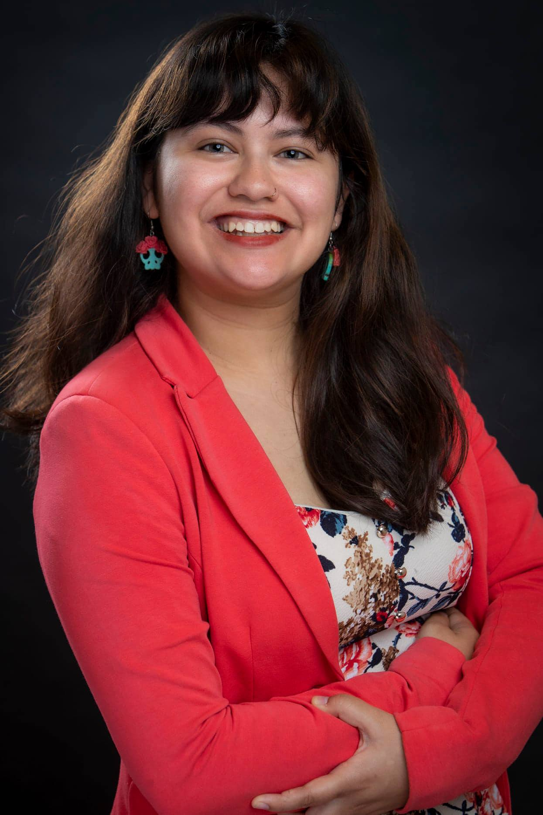

**Marissa Jauregui**

Puget Sound Educational Service District (PSESD)

800 Oakesdale Ave SW  
Renton, WA 98057-5221 (425) 917-7763  
Mjauregui@psesd.org

Bio: Marissa has been working with and for the Coalition for Drug Free Youth in White Center since 2020 and has used her passion for engaging community to create bridges between systems. Marissa believe in the power of community engagement and education to influence, sustain, and empower communities.

#### Coalition Mission

The Coalition for Drug-Free Youth educates, inspires and empowers our community to support youth and to create a safe, healthy environment aimed at addressing alcohol, tobacco and other drug problems.

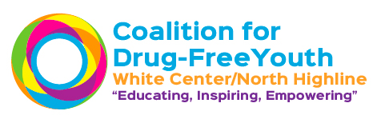

## White Center/North Highline

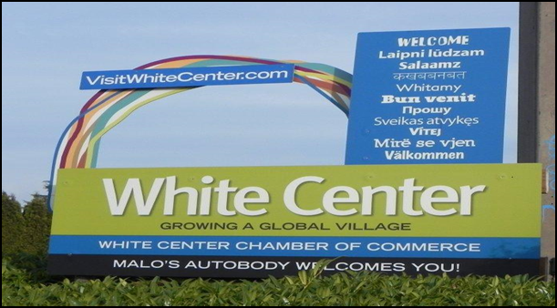

### About the Community Prevention and Wellness Initiative (CPWI)

CPWI is a partnership of state agencies, counties, schools and local prevention coalitions supporting communities in preventing alcohol and other drug abuse and its negative consequences.  CPWI priorities include reducing underage drinking, marijuana use and opioid misuse/abuse among middle and high school aged youth. By providing evidence-based practices and promoting the positive changes in communities, we can build healthier communities.

### About the Coalition: Communities & Schools Working Together

In 2012, King County Behavioral Health and Recovery Division awarded a CPWI grant to Navos Mental Health Solutions to develop a community coalition (Coalition for Drug-Free Youth - CDFY) focused on alcohol and other drug prevention in the White Center/North Highline community. Navos served as the Coalition’s Fiscal Agent through July 2018.

In August 2018, CDFY partner Puget Sound Educational Services District (PSESD) assumed Fiscal Agent responsibilities, ensuring the continuation of the Coalition’s prevention efforts.

The CDFY teams with community members and organizations in the White Center/North Highline area as well as staff, students and families in the Highline School District (HSD), primarily Cascade Middle School, Evergreen High School and New Start High School in its prevention efforts. HSD also provides funding support for the Student Assistance Professional at Cascade Middle School and Evergreen High School.

Our Coalition enjoys the support and participation of numerous programs and service providers, including the HSD, the business community, government and law enforcement, civic and volunteer organizations such as the White Center Kiwanis, health care, media and youth-serving organizations guiding students in implementing positive norms activities on-campus and the nearby community.

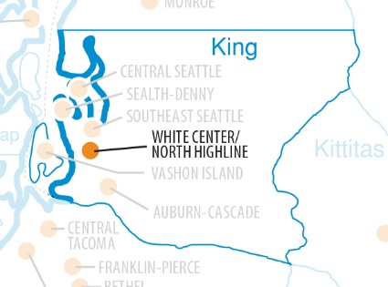

### About Our Community

##### **County Contact**

Jackie Berganio

Community Coordinator

(206) 263-8931

[jackie.berganio@kingcounty.gov](mailto:jackie.berganio@kingcounty.gov)



##### 

##### **Student Assistance Professional**

##### Danielle Bock

##### Puget Sound Educational Service District (PSESD)

Student Assistance Prevention- Intervention Services Program

(253) 253-778-7752

[dabock@psesd.org](mailto:dabock@psesd.org)

Cascade Middle School Evergreen Campus New Start High School

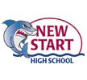 The White Center/North Highline community is a culturally diverse tapestry of refugees and immigrants, people of color, ethnicity, country of origin and spoken languages. It’s a youthful community, with more than 40% of children and teens in King County living in South King County.

Common first languages spoken at home among immigrant residents include Spanish, Somali, Vietnamese and Khmer/Cambodian, those of other African and Arabic countries, and the more established Asian, Pacific Islander, African American and White populations.

The region is characterized by high levels of poverty, limited access to health care and employment opportunities, and cross-cultural differences that historically have contributed to lack of unity in the community.

Other factors combine to put students at higher risk of substance use, including low attachment to community and school, lower academic achievement, and feelings of alienation, particularly among youth.

Several licensed recreational marijuana stores in the area, the increased popularity of e-cigarettes, particularly vaping, and changing community norms, adds to the Coalition’s prevention challenges.

Given these challenges, this community has responded by embracing its diversity, creating one of the richest and more inclusive living experiences in the region.

The Coalition, one of more than 80 CPWI prevention organizations throughout the state, together with students, parents, schools and community organizations have collaborated to support a variety of youth development opportunities. These opportunities range from Prevention Teams at the schools, LifeSkills training, Project SUCCESS, mentoring, community-building and public awareness activities, to parenting skills programs, multi-cultural nights, community cultural festivals and events recognizing and celebrating our diversity and building a stronger foundation and future for our youth.