ATTEND. ACHIEVE. SUCCEED.
Figure 1Title, Attend, Achieve and Succeed
Figure 2Picture of Students in front of school
Everyday Counts, Every Student Matters
Attendance Awareness
Toolkit 2018 - 2019

ATTENDANCE AWARENESS TOOLKIT TAE OF CONTNTS
PAGE MESSAGE FROM OUR SUPERINTENDENT 4
TOOLKIT: Why, What, How & When 5
INCLUSIVE COMMUNITY & KEY MESSAGING 6
FAMILY ENGAGEMENT AND CORE BELIEFS 7
IMPORTANTCE OF ATTENDANCE . . . . . . . . . . . . . . . . . . . . . . . . 8 - 9 THE DUAL CAPACITY-BUILDING FRAMEWORK 10
EARLY LEARNING PARTNERS KEY MESSAGING 11
ATTENDANCE INTERVENTION AND CULTURE . . . . . . . . . . . 12 - 13
STRATEGIES AND TIPS . . . . . . . . . . . . . . . . . . . . . . . . . . . . . . . 14 - 15
FEATURE PLC SCHOOLS 16-19
SUMMER SEPTEMBER SUSTAINABILITY 20
ATTENDANCE AWARENESS MONTH: Five Ways
to Get Involved 21
DELIVERING THE MESSAGE: Press Releases, Flyers, Poster, Articles, Social Media Graphics
and Content . . . . . . . . . . . . . . . . . . . . . . . . . . . . . . . . . . . . . . 22 - 23
ABOUT EWS: Contact info 24

FROM THE SUPERINTENDENT

ATTEND. ACHIEVE. SUCCEED.

The Puget Sound Educational Service District (PSESD) is one of nine regional educational agencies serving school districts in Washington. PSESD’s mission is to create Success for each child and eliminate the opportunity gap by leading with racial equity. We work in partnership with educators, schools, districts and community-based organizations in our daily work toward our END.
The ATTEND. ACHIEVE. SUCCEED.
Toolkit is inspired by the amazing work done by Attendance Works, the PSESD Early Warning Systems program along with the Communications, Government and Public Relations Department, partnering to build public awareness and political reach,
developing coalitions to advance policy while providing technical assistance and tools for local practice. We are supportive of this work, its objectives and are excited to share the collaboration and development of these resources for Puget Sound region.
In this toolkit you will find:
- Strategies for engaging families in conversation about attendance
- Example programs from schools and Early Learning on addressing absenteeism
- Sample messages for schools to use when messaging about attendance
- Tips and Key Messaging for out of school providers

Attendance is proven to be one of the predictors of academic achievement and can have major impact on key milestones, including third grade reading, 9th grade achievement, high school graduation, and postsecondary persistence.
One of our major strategic goals is targeting chronic absenteeism statewide and we believe this toolkit and the partnerships that led to its development are great resources that will aid the students, families and school districts we serve.
Everyday Counts, Every Student Matters

Sincerely,

John P. Welch, Superintendent

WHAT THIS TOOLKIT IS, HOW TO USE IT AND WHEN

- WHY ATTENDANCE & CHRONIC ABSENCE

Attendance has been proven to be one of the most powerful predictors of academic achievement and can have a dramatic impact on key milestones, including third grade reading, ninth grade achievement, high school graduation, and postsecondary persistence. Chronic absenteeism is missing 10% of school, regardless of the reason. A focus on chronic absenteeism examines the link between loss of class time and academic achievement. An
awareness of chronic absenteeism and its potential impact will empower students, families, and communities to make informed decisions regarding missing school.

According to OSPI, In
2016, WA State absentee rate was at 16.7% - 193,929
students were at risk

  - WHO SHOULD USE THIS TOOLKIT?
The purpose of this toolkit is to rally communities around the cause of improving absenteeism. With that said, we encourage all school and district staff, as well as community organizations, religious institutions, local businesses, healthcare providers, and family members to use this toolkit to improve attendance among the youth in your community.

- CAN WE MAKE CHANGES?

In an effort to support school districts in our region, this toolkit was developed by Puget Sound Educational Service District’s (PSESD) Communications and Public Relations team in partnership with the Early Warning Systems program.

The information found in this plan includes resources from Attendance Works, OSPI, and original content and images from PSESD. Use of the materials from these sources has been granted to school districts in the Puget Sound Region. Please credit Attendance Works and PSESD with our logos and/or a line reading “used with permission of Attendance Works and PSESD.” as appropriate.

Districts are encouraged to customize the messaging with district specific information.

In addition to using this messaging through their own platforms, we encourage districts to share, retweet and repost information shared through the PSESD social platforms.
Facebook: https://www.facebook.com/PSESD
Twitter: https://twitter.com/PSESD

How Do We Access IT?
In addition to this PDF, there is a web page dedicated to providing more in-depth and update information: psesd.org/attendancetoolkit

INCLUSIVE COMMUNITY OUTREACH
Any communication you have with students and families in your community should be responsive, inclusive and culturally appropriate. Attending to culturally sensitive communication supports two of the four anti-bias domains: Identity and Diversity. Culturally relevant family engagement strategies communicate to students that their family identities are understood and valued. It also demonstrates respect for families with a diverse range of backgrounds and structures.

KEY MESSAGING
CUSTOMIZING YOUR ATTENDANCE MESSAGE TO YOUR AUDIENCE
KEY MESSAGES THAT EVERYONE —SCHOOLS, PRESCHOOLS, PUBLIC AGENCIES, COMMUNITY ORGANIZATIONS, FAITH BASED INSTITUTIONS, ELECTED OFFICIALS, AND PARENTS THEMSELVES—CAN USE TO HELP SPREAD THE WORD ABOUT THIS IMPORTANT ISSUE.
- Good attendance helps children do well in school and eventually in the workplace. Good attendance matters for school success, starting as early as prekindergarten and throughout elementary school. By middle and high school, poor attendance is a leading indicator of dropout. Developing the habit of attendance prepares students for success on the job and in life.
- Excused and unexcused absences easily add up to too much time lost in the classroom.
  - Students are at risk academically if they miss 10 percent of the school year, or about 18 days. Once too many absences have occurred, they can affect learning, regardless of whether absences are excused or unexcused.
  - Sporadic, not just consecutive, absences matter. Before you know it – just one or two days a month can add up to nearly 10 percent of the school year.
  - Avoid unnecessary absences. Some absences are unavoidable. Occasionally, children get sick and need to stay home. What is important is getting children to school as often as possible.
- Chronic absence (missing 10 percent of the school year or more) does not just affect the students who miss school. If too many students are chronically absent, it slows down instruction for other students, who must wait while the teacher repeats material for absentee students. This makes it harder for students to learn and teachers to teach.
- We need to monitor how many days each student misses school for any reason— excused, unexcused or suspensions— so we can intervene early. Districts and schools use data to identify how many and which students are chronically absent so they can target extra supports that
can improve attendance and interrupt a pattern of chronic absence. Absences represent lost opportunities to learn in the classroom.

Adapted by PSESD, with permission, from materials provided by Attendance Works (www.attendanceworks.org)

- Chronic absence is a problem we can solve when the whole community, along with parents and schools, get involved in improving attendance. All of us can make a difference by helping students and families feel engaged in learning. Their schools are setting the expectation that school attendance matters and working together to identify and help families overcome barriers of getting to school. Community partners are especially important for helping schools and families address and overcome tough barriers, such as limited access to healthcare, unstable housing, poor transportation or neighborhood violence.
- Relationship building is fundamental to any strategy for improving student attendance. Students are more likely to go to school if they know someone cares whether they show up. Trusting relationships – whether with teachers, mentors, coaches or other caring adults – are critical to encouraging families and students to seek out help to overcome barriers to attendance.
- Reducing chronic absence can help close achievement gaps. Chronic absence especially affects achievement for low-income students who depend more on school for opportunities to learn. Because they are more likely to face systemic barriers to getting to school, low-income children, many of whom are children of color, have higher levels of chronic absence starting as early as prekindergarten. Especially among older students of color, chronic absence could signal the need to reform inappropriate and biased student discipline policies and practices that are pushing students out of class.

TIPS FOR TALKING TO FAMILIES
Stress that good attendance will help their children do well in high school, in college and at work.

- Children can suffer academically if they miss 10 percent of the school year or about 18 days. That can be just one day every two weeks, and that can happen before you know it.
- Some absences are unavoidable. We understand that children will get sick and need to stay home occasionally. The important thing is to get your children to school as often as possible, on time and to communicate with the school when your child will be absent.
- Sporadic absences, not just those on consecutive days of school, matter. Before you know it – just one or two days a month can add up to nearly 10 percent of the school year.
- If too many absences occur, whether they are excused or unexcused, it is still a problem because they represent too much lost learning time in the classroom.
- Attendance matters as early as kindergarten. Studies show many children who miss too many days in kindergarten and first grade can struggle academically in later years. They often have trouble mastering reading by the end of third grade.
- Preschool is a great time to start building a habit of good attendance. Young children with poor attendance in preschool also lose out on valuable learning time and if chronic absence continues into kindergarten, it can pull down academic achievement.
- By middle and high school, chronic absence is a leading warning sign that a student will drop out.
- Too many absent students can affect the whole classroom, creating disruptions and slowing down instruction.

For student messaging, translations, flyers and more visit: psesd.org/attendancetoolkit
Adapted by PSESD, with permission, from materials provided by Attendance Works (www.attendanceworks.org)

WHAT IS FAMILY ENGAGEMENT?
3. Partnerships with families are essential
Family Engagement is any way that a child’s adult caretaker (biological parent, foster parents, siblings, grandparents, etc.) at home, at school, and in the community, effectively supports learning and healthy development.
1
- FAMILY ENGAGEMENT CORE BELIEFS
1
2
All parents have dreams for their children and want the best for them.
All parents can support their children’s learning.
- HOW FAMILIES CAN SUPPORT STRONG ATTENDANCE
4
The responsibility for building partnerships between school and home rests primarily on the school staff, especially school leaders.

  - Let your child know you believe school is important
  - Set a regular bed time/curfew on school nights
3
Partnerships with families are essential to academic achievement.
  - Have a plan for getting your child to school on time
  - Notify the school if your child has prolonged absence due to illness
  - Do not support children leaving school early during the school day
  - Schedule appointments (doctor’s visits) before and after school hours
  - Plan family vacations during school vacations
  - Have your child go to school, unless they are truly sick and cannot make it through the day
  - Establish healthy eating habits so your child does not get sick as often
  - Regularly check your child’s attendance records
  - Make sure your child does not miss more than 10 days per year

Adapted by PSESD, with permission, from materials provided by the Department of Education

ATTENDANCE ROOT CAUSES AND THEORIES OF ACTION EXAMPLES

Root Cause Theory of Action

Families do not understand the impact that school attendance has on their child’s academic achievement.

Teachers do not feel that they have the capacity to build relationships with families and communicate attendance expectations.
Families don’t believe that their efforts to support attendance will have a positive impact.

Families don’t come to school to discuss their child’s academic or attendance progress because they don’t feel welcomed.
Families have negative interactions with the school because their child is not meeting academic or behavior expectations (i.e. failing grades, suspensions, etc.)
Families have had negative experiences with school in the past.

Families do not attend school events because of language barriers.
If we communicate with families, in various ways, the impact that school attendance has on academic
achievement, then we will have more families that understand
why attendance is important, which will lead to increased school attendance.
If we provide professional development for teachers on how to build strong partnerships with families and communicate attendance expectations, then we will have more teachers that feel confident in developing home-school partnerships, which will lead to increased support from families.
If we provide families with tools, skills and resources to support strong attendance, then we will have families that feel confident in supporting their child’s success, which will lead to increased school attendance.
If we create a welcoming and inviting school climate and culture, then we will have more families that feel they are wanted at school, which will lead to increased participation at school events and attendance meetings.

If we partner with families to identify and provide the supports needed to ensure academic and behavior success, we will have more students and families that have positive school experiences, which will lead to increased school attendance.

If we build effective relationships with families (based on the Family Engagement Core Beliefs), then we will have increased trust between home and school, which will lead to improved home-school partnerships with families and increased school attendance.
If we ensure that we have interpretation and translation at all family meetings, then we will have more participation from our non-English speaking families, which will lead to more families understanding how to support strong school attendance.

Adapted by PSESD, with permission, from materials provided by the Department of Education

DUAL CAPACITY-BUILDING FRAMEWORK

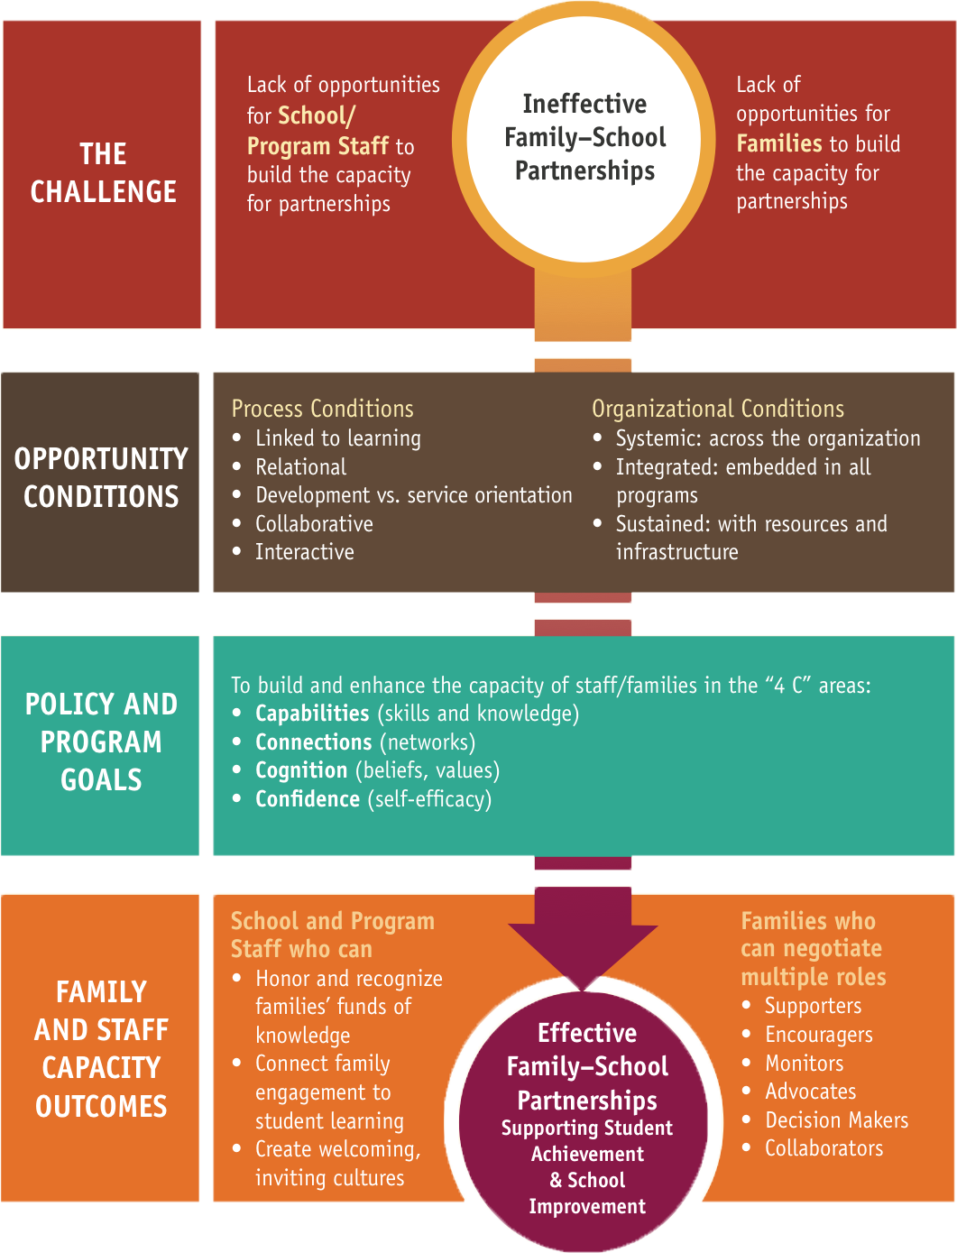

Adapted by PSESD, with permission, from materials provided by Attendance Works (www.attendanceworks.org)

KEY MESSAGING FOR EARLY LEARNING PARTNERS
OPPORTUNITES FOR EARLY LEARNING PROVIDERS TO MESSAGE IMPORTANCE OF ATTENDANCE TO FAMILIES
Throughout the course of a school year, family support and teaching staff meet frequently with parents. Each meeting is an opportunity to increase awareness of the importance of promoting good school attendance for the long-term academic success of their children and the steps that they can take on their own and in partnership with others to get their students to school every day.

1. Preschool may seem like a time just to play, but it’s really about building a foundation for your child to succeed in school.
2. If chronic absence continues into kindergarten, it can leave a child struggling to read in later grades. These students are more likely to be held back in a later grade and more likely to miss too much school when they’re older.
3. We understand that children get sick and need to stay home sometimes. The important thing is to get your children to preschool as often as possible. Avoid absences whenever possible.
4. Share and discuss daily attendance
5. Children who miss too many days of preschool can miss out on the important lessons learned there.
6. Preschoolers are learning to be students, and one of the most important lessons they can learn is showing up on time.

ATTENDANCE PLAN TALKING POINTS FOR TEACHING AND FAMILY SUPPORT STAFF IN EARLY LEARNING

- WHAT WE MESSAGE TO ALL FAMILIES
- Review student attendance with all families.
- Review attendance contract (that was shared during family engagement) with all families.
- Review schoolwide attendance data. During the 2015-2016 school year, 61% of Meadow Crest students missed more than 10 days of school.
- Last year, this improved and 53% of students missed more than 10 days of school. This year our goal is to reduce this percentage again to 43%.

- OUR MESSAGE TO STUDENTS/FAMILIES WITH NO ATTENDANCE CONCERNS
- Great work — Let’s celebrate!
- Your child is more likely to keep coming to school because you have developed a pattern of going to school.
- Your child is learning important literacy, math, handwriting, and social skills.
- Your child is NOT one of the estimated 5 million to 7.5 million U.S. students that will miss nearly one month of school in a school year.

FOR STUDENTS/FAMILIES WITH ATTENDANCE CONCERNS
- How can we help you get your child to school?
- Are transportation issues making it difficult for your child to come to school?
- • Now that we have been at school for a couple months, can we re-open the conversation about riding the bus?
  - Would you be open to carepooling with another family that lives nearby you?
- Review the “sick chart”. As long as your child isn’t showing symptoms on the chart, they are welcome to come to school.
- Have you talk to a pediatrician about chronic illnesses?
- If the student doeesn’t want to come to school;
- • What is your child saying about not wanting to come to school?

LET’S MAKE AN ATTENANCE PLAN

THANKS!
A special thanks for Meadow Crest Early Learning Center for sharing these attendance talking points.

12 Adapted by PSESD, with permission, from materials provided by Attendance Works (www.attendanceworks.org)

SCHOOL DISTRICTS ATTENDANCE INTERVENTION

FIVE UNIVERSAL STRATEGIES FOR BUILDING A CULTURE OF HIGH ATTENDANCE EXPECTATIONS
Tackling Chronic Absence: 5 Universal Strategies for Building a Culture of High Attendance Expectations
(Baltimore City Public Schools Adapted from www.attendanceworks.org)

- Recognize good and improved attendance
- Intentionally and proactively engage students and families
- Monitor attendance data and daily practices
- Facilitate personalized and early outreach to students with attendance concerns
- Identify programmatic responses to barriers to school attendance

Increased Attendance Involves a 3-Tiered Approach that Fits with Most Reform Efforts A 3-TIERED APPROACH
A systematic and sustainable approach to reducing chronic absence requires a combination of universal and preventative programs that build a culture of attendance throughout the school and the community, early outreach that enables school and community staff to build relationships with families and stem absenteeism early on, and intensive intervention that focuses resources on the most high need families.

Students who were chronically absent in prior year or
starting to miss 20% or more of school
High Cost
Recovery Programs

A small fraction of a school’s students

Students at risk for chronic absence
Intervention Programs
Some of a school’s students

All students in the school
Universal/Preventive Programs
All of a school’s students
Low Cost

Full documents, additional PowerPoint Presentations, PDFs, and
Truancy information can be found at psesd.org/attendancetoolkit

STRATEGIES FOR SCHOOLS TO BUILD A CULTURE
OF ATTENDANCE

Emphasize attendance from day one
- Participate in attendance awareness month and use back-to- school night to communicate with parents
11
- Send home information and tips about attendance
throughout
- Engage parents in attendance awareness activities
the year
2
Engage Parents
- Create a welcoming environment that engages families
- Use parent-teacher conferences to talk about attendance
- Outreach to families that are not able to meet at schools

3
Promote a culture of attendance all year long
- Engage students in tracking their own attendance
- Greet students warmly, take attendance daily and check in with them when they come back after an absence
- Include attendance in home visits

4
Partner with community agencies
- Evaluate possible barriers to attendance, such as health, transportation and housing problems
- Engage community partners who can help
- Encourage your school to develop a sheet of resources for families who need support

TIPS
5
for Out of School Providers
1 2

Engage students in enriching activities Make sure your program offers the kind of innovative activities that will keep students coming to your program and to school. Some children say they attend school just so they can attend afterschool enrichment activities.

3

Serve as a resource for parents to support good attendance
Use your interactions with parents at pick-up time to share why attendance matters and, if children are absent, find out about what might be getting in the way of attending school.

Use chronic absence data when developing new programs
Consider locating new programs in communities with high chronic absence rates, where students and families need help building good attendance habits and bringing absenteeism under control.
4

5

Record program attendance accurately Make sure that you emphasize good attendance in the afterschool program. Keep regular records and examine the data for patterns

Encourage students to attend school regularly
Share the importance of regular attendance for academic achievement. Encourage
staff to take the time to acknowledge and notice each child every day they attend the program and express concern if they are absent. Students are more likely to attend if they know someone cares.

PLC FEATURED SCHOOLS
SHARING EXAMPLES OF THEIR WORK TO REDUCE ABSENTEEISM

In 2017-18, the Puget Sound Education Service District (PSESD), the King County Housing Authority (KCHA) and High Expectations partnered in effort to address chronic absenteeism at the elementary school level. Eight schools were awarded mini grants to form attendance teams. The purpose for the attendance teams was to implement family engagement strategies to increase student attendance and academic outcomes.

The attendance teams from the 8 elementary schools met on a regular basis at their schools to set goals, reviewed attendance data and developed family engagement strategies to address chronic absenteeism.
In addition to regular meetings, the PSESD and KCHA provided professional development and technical assistance in the following areas via Peer Learning Community meetings and coaching calls:

Equipping team members
(families, teachers, administrators, community partners) with core skills needed to function effectively as a team.

Evaluating existing family engagement practices and aligning activities to their school attendance goals.

Providing schools with the implementation support needed
to successfully implement and evaluate their family engagement activities.

Assisting schools in linking evidence based practices
to their school’s family engagement attendance plan.

Heare are some examples of their work, full presentations can be can be found at psesd.org/attendancetoolkit

HAZEL VALLEY

HAZEL VALLEY ELEMENTARY
On time- every day!

HILLTOP
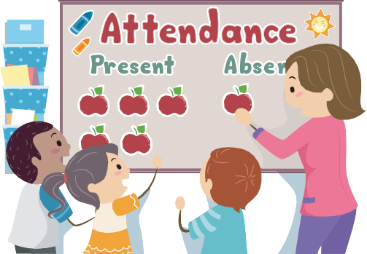
Hilltop Elementary

ATTENDANCE 2017-18

SOUTHERN HEIGHTS
Attend Today, Achieve Tomorrow

SOUTHERN HEIGHTS ATTENDANCE TEAM 17-18

MIDWAY
Midway Elementary
Attendance

WHITE CENTER HEIGHTS
White Center Heights Elementary

FAMILY STORIES DRIVE ATTENDANCE

PINE TREE
Pine Tree Elementary School

2017-18
FAMILY ENGAGEMENT ACTION PLAN

Full presentations can be can be found at psesd.org/attendancetoolkit

SUMMER. SEPTEMBER. SUSTAINABILITY.
Improving student attendance is an essential, cost-effective but often overlooked strategy for ensuring our students are on-track to learn and succeed. Chronic absence is a leading, early warning indicator of
academic trouble and later dropout. The good news is that chronic absence is a problem we can solve. Too often, we don’t realize how quickly absences add up: Missing just two days every month can cause a child to fall behind. Help students stay in engage during the summer months and establish good attendance at the beginning of the year.
SUMMER

- Summer provides the opportunity to prepare for the school year and set the tone for the rest of the year.
- Use the summer to build trusting relationships with families and to equip staff with skills that will improve students’ attendance.
- Build excitement and momentum with students and families by engaging them in learning so they recognize that showing up every day helps build new skills.
ATTENDANCE AWARENESS IN SEPTEMBER #SchoolEveryday

- The first month of school is the perfect time to build a sense of excitement about the school year and to introduce students and families to expectations about attendance.
- The first month can also be a gauge for the coming year and gives teachers and community partners the opportunity to step in and to stem early signs of chronic absenteeism.
- Key parent-focused events, such as Back to School Night and parent teacher conferences, can be excellent opportunities to reinforce messaging about the importance of good attendance.

BE SURE TO PARTICIPATE IN THE NATIONAL ATTENDANCE WORKS CAMPAIGN VIA SOCIAL MEDIA EVERY DAY IN SEPTEMBER USING THE #SCHOOLEVERYDAY HASHTAG.
SUSTAINABILITY

- Use positive relationships to engage students and families in attendance activities. Outreach to families who are not able to meet in a school setting.
- Celebrate good and improved attendance throughout the year.
- Develop strategic partnerships with districts and community partners to address specific attendance issues and to mobilize support
KEY CONSIDERATIONS FOR EFFECTIVE OUTREACH AND INTERVENTION

- Trusting relationships with families are a critical component for making an impact, and taking the time to build these relationships is a worthwhile investment.
- Tailor intensive intervention strategies to student population and the unique barriers that families face.
- Home visits are a good way to build relationships with families, share school expectations, learn about students, and hear parents’ hopes and dreams for their children.

Adapted by PSESD, with permission, from materials provided by Attendance Works (www.attendanceworks.org

ATTENDANCE AWARENESS
MONTH
Join us for the sixth annual Attendance Awareness Month! Attendance Awareness Month is a nationwide event recognizing the connection between school attendance and academic achievement.

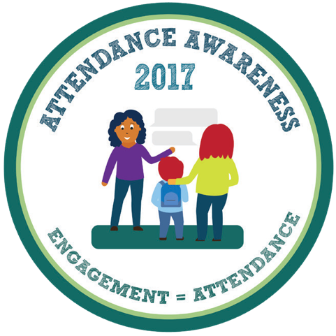
Participate in Attendance Awareness Month this September in one or all 5 of these ways:

- Engaging Parents and Students Right Away!
Parents and families are essential partners in promoting good attendance because they, ultimately, have the bottom-line responsibility in making sure their children get to school every day. When children
are young, they are especially dependent upon adults or older siblings to help them get to school or preschool. Just as parents should focus on how their children are performing academically, they have a responsibility to set expectations for good attendance and to monitor their children’s absences so that missed days don’t add up to academic trouble. Start the Conversation right away at the beginning of the year!
- Reach out to your local media contacts
or respond to reporters’ calls and suggest articles on school attendance and what your organization or community is doing to reduce absenteeism.
- Op-eds and Blogs
Ask your Superintendent, Principal and/or School Board member to submit an Op-ed and/or write a blog for your district website. Compose a commentary stressing the importance of attendance and the role
a school or community is playing to reduce absenteeism. If you can’t sell it as an op-ed piece, shorten it and offer it as a guest blog or a letter to the editor. Remember TV and radio stations allow on-air commentaries.
- Run your own Daily Social Media Attendance Campaign.
Post 30 tweets, Facebook entries, Instagram photos about attendance data — one for every day in September.
Use the national hashtag: #schooleveryday

- Attendance Action Map
Post your activities and events on the AttendanceWorks.org Attendance Action Map if your school or community is monitoring chronic absence. Fill out the participation form to submit your plans.

For more information, including resources, visit www.psesd.org/attendancetoolkit

Adapted by PSESD, with permission, from materials provided by Attendance Works (www.attendanceworks.org)

DELIVERING THE MESSAGE
HELP FAMILIES UNDERSTAND THE IMPORTANCE OF DAILY ATTENDANCE

The message we must deliver is that every absence makes a difference at every grade level. Every day missed is a day of instruction that can’t be recovered. Research shows that
two to four missed days in the first month of school can predict chronic absence throughout the year.
Spreading the message about good attendance at the beginning of the school year can get everyone off to a good start.

SOCIAL MEDIA
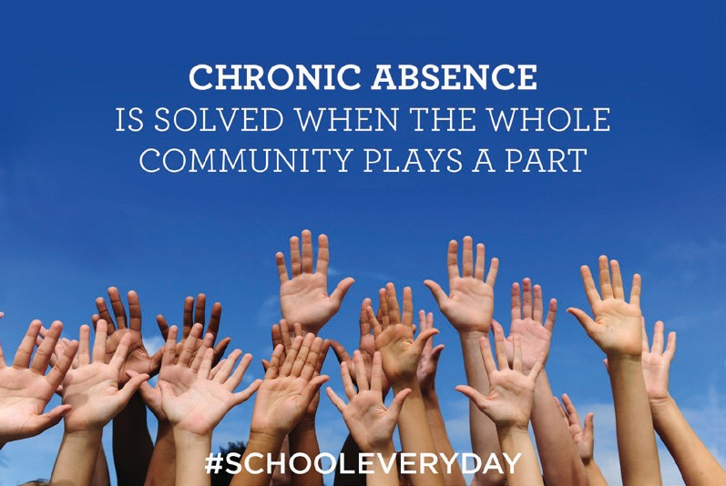
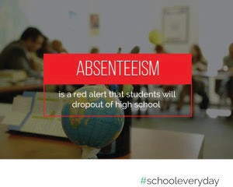
Sample posts and media graphics

Adapted by PSESD, with permission, from materials provided by Attendance Works (www.attendanceworks.org)

FLYERS AND POSTERS

ATTEND. ACHIEVE. SUCCEED.
EVERYDAY COUNTS, EVERY STUDENT MATTERS
As most kids have returned to the classroom by September, it seems appropriate that this month marks “Attendance Awareness Month.”

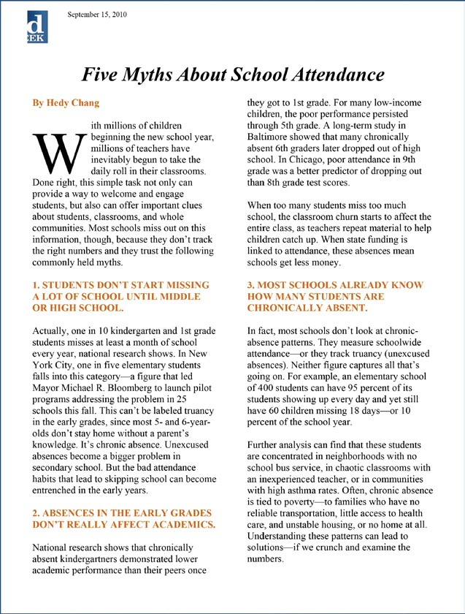
The goal of the month is to raise awareness around the importance of students attending school daily and how it connects to academic achievement.

According to numerous studies, missing several days of school significantly reduces the likelihood that students will graduate from high school.
With attendance being a crucial factor in keeping kids on the right path to graduation, Attendance Works, which is a leader during this month, has substantial information on attendance and the impact on student achievement.
We’ve compiled some of the research on the next page on why attendance matters.
Find out more information about Attendance Awareness Month and Attendance Works on their website (www.attendanceworks.com).

Adapted with permission from materials provided by Attendance Works (www.attendanceworks.org | Mapping-the-Early-Attendance-Gap)

Samples of Student Posters Fast Facts Five Myths of School Attendance

PRESS RELEASES

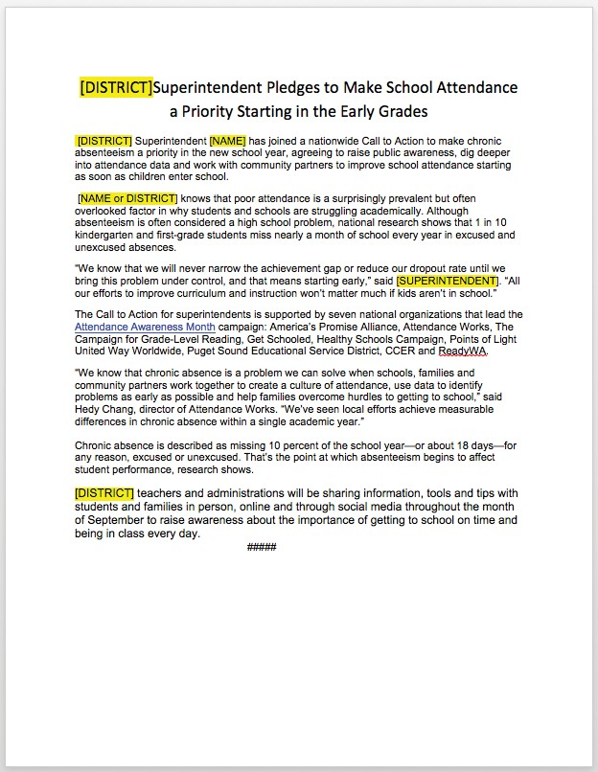

We suggest you send this in late August or early September just before the first day of school
ARTICLES

Making the Case for Tracking Chronic Absence
A growing body of research is revealing the prevalence of chronic absence and its critical role in student achievement. Fortunately, research is also showing that chronic absence can be addressed when school districts, communities, and policymakers work together to monitor the problem and implement solutions that address the underlying causes.
General
  - Balfanz, Robert and Byrnes, Vaughan (2013), Meeting the Challenge of Combating Chronic Absenteeism,
Everyone Graduates Center, Johns Hopkins University School of Education. This report examines the impact of New York City Mayor Michael Bloomberg’s task force on truancy, chronic absenteeism and school engagement, a program that spanned 2010 to 2013 and reached more than 60,000 students in NYC public schools. The study found that students who missed at least 20 days of school per year — the definition of chronic absenteeism — had lower grades and were more likely to drop out than
students with better attendance. Yet, the researchers also found these effects of absenteeism are reversible with the help of mentors, incentive programs and awareness campaigns.
  - Balfanz, Robert and Byrnes, Vaughan (2012), The Importance of Being in School: A Report on Absenteeism in the Nation’s Public Schools, Johns Hopkins University Center for Social Organization of Schools. This report analyzes data on chronic absenteeism at the state level to begin the process of mapping its extent and
characteristics. Although currently only a handful of states collect data on chronic absenteeism, results from a sample of states suggest that an estimated 10-15% of students in the U.S. are chronically absent each year. The report also highlights some promising practices among cities, school districts and nonprofits to combat chronic absenteeism. The authors offer policy recommendations on tracking and reporting chronic absence data and evidence-based interventions.
  - Bruner, Charles; Discher, Anne; and Chang, Hedy (2011), Chronic Elementary Absenteeism: A Problem Hidden in Plain Sight, Child and Family Policy Center and Attendance Works. This study confirms the premise that districts and schools may fail to detect high levels of chronic absence because the problem is easily masked by average daily attendance, one of the most commonly calculated attendance measures. While many educators assume a 95% ADA rate is an indicator
of good attendance, the authors find that this sometimes mask a problem with a group of students missing excessive days.
Early Education and Elementary
  - Attendance in Early Elementary Grades: Association with Student Characteristics, School Readiness and Third Grade Outcomes, Applied Survey Research (2011). This study suggests that attendance in the early grades is critical to sustaining the school readiness skills that preschool or Head Start programs can help children to develop. The report found that students who arrived at school academically ready to learn — but then missed 10% of their kindergarten and first grade
years — scored an average of 60 points below similar students with good attendance on third-grade reading tests.

  - Chang, Hedy and Romero, Mariajose (2008), Present, Engaged and Accounted For: The Critical Importance of Addressing Chronic Absence in the Early Grades, National Center for Children in Poverty. This report documents the consequences, prevalence, potential causes and possible solutions to children missing extended periods of school in grades K-3rd. Although students must be present and engaged to learn, thousands of this country’s youngest students are
academically at-risk because of extended absences when they first embark upon their school careers. Nationally, an estimated one in 10 kindergarten and first-grade students are chronically absent. The report recommends that schools, communities and families monitor and promote attendance, as well as to identify and address barriers to good attendance.

- Research Summary on Chronic Absence
- Present, Engaged and Accounted for
LETTERS AND EMAILS

Guide to Preventing Truancy and Understanding the “Becca Bill”

Truancy
In our state, the law requires that children ages 6 to 17 who are enrolled in public schools, attend school Monday through Friday, unless there is a good reason for being absent. In this case the parent or legal guardian must excuse the absence by notifying the school.

When students miss school and their parents have not excused the absence, they can be considered truant. Truancy is defined as being absent from school or from the majority of a student’s classes without a valid excuse.

School districts around the state have different rules and regulations about student attendance and how parents should excuse absences. Be sure to read the attendance policies in your school district and discuss them with your student.

The Becca Bill
The “Becca Bill” (SB 5439) is our state’s truancy law. It is intended to stop truancy before it becomes a problem. Schools and families should work together as a team to ensure school attendance and student safety. However, if a student has unexcused absences, this law requires that schools and school districts take the following actions:
- One (1) unexcused absence. The school must inform the parent when there is one unexcused absence. This is often done by a phone call home.

- Two (2) unexcused absences. After the second unexcused absence, the school is required to schedule a meeting with the parent/legal guardian and student to discuss the causes of the unexcused absences and find solutions to prevent further absences. This is a team effort.

- Five (5) unexcused absences within 30 days. The school must enter into a written truancy agreement with the family, where the parent, student and school agree on the necessary steps to resolve the student’s attendance problem.

- Seven (7) unexcused absences during a month or at the tenth (10th) unexcused absence within a school year. The school district will file a petition in juvenile court to order the student to attend school. If this court order is violated, the court will call for a Contempt Hearing and the student could be ordered to do community service or spend time in juvenile detention. The parent may be fined up to $25.00 for each day of unexcused absence.

The school district may also refer the family to a “Community Truancy Board” if there is one in the community. A Truancy Board is a group of citizens who help resolve truancy cases away from the court.

Schools must send the student a notice of the truancy court petition by certified mail with return receipt or by in-person delivery. The petition includes many important dates and deadlines that must not be missed by the student and the family. A student and/or parents can be represented by a lawyer in truancy court.
Sample letters, emails and guides.

Full documents, graphics and content for social media, flyers, posters, press releases, articles, letters, and emails can be found at psesd.org/attendancetoolkit

Adapted by PSESD, with permission, from materials provided by Attendance Works (www.attendanceworks.org)

ABOUT EWS
Early Warning Systems (EWS) uses research proven thresholds of the ABC’s (Attendance, Behavior and Course Performance) to identify students who are struggling early and intervene to bring students back on track for high school graduation and postsecondary success. Research proven, nationally recognized and highly predictive indicators generally include:
    - A – Attendance: 90% or lower
    - B – Behavior: Suspension/Expulsion
    - C – Course Performance:
      - Failure of core course in middle school
      - Failure of any course in high school
It is essential that all students graduating from high school are prepared and ready for postsecondary education. Georgetown University Center on Education in the Workforce projects that 67% of Washington State jobs will require postsecondary education
by 2018. Early Warning Systems allow districts, schools and community partners to proactively use data to reduce disproportionality and target interventions for those students who most need additional support to reach graduation and beyond. It is a key strategy to help eliminate the opportunity gap and ensure success for each student. (psesd.org/EWS)

- CONTACT INFO
Questions about the Toolkit? Please Contact one of us:

Marques Gittens, M.Ed.
Program Director, Early Warning Systems P: (425) 917.7758
mgittens@psesd.org
Nicole Chu
Program Manager, Early Warning Systems P: (425) 917.7854
nchu@psesd.org

- www.psesd.org/attendancetoolkit

