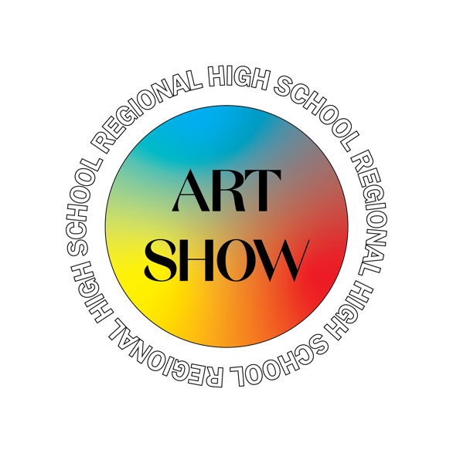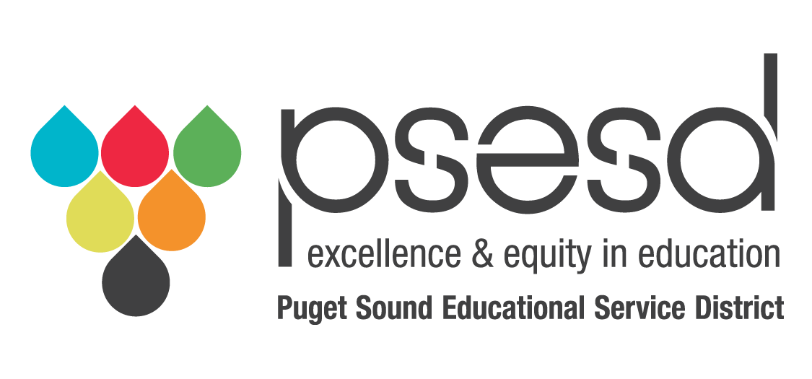

2021 Regional High School Art Show
It is time to start preparing for the 2021 Regional High School Art Show! Because of the Covid year, this spring’s show will be a virtual experience. There are significant changes to the submission process, display of artwork, judging and awards ceremony. Below is important information outlining details for your easy reference.

2021 Regional High School Art Show Timeline
- January 18, 2021: Online registration open and Artwork accepted online
- February 12th, 2021: Last day to submit artwork before judging
- February 22 – 26th, 2021: Judging
- March 5, 2021: Award letters emailed
- March 31, 2021: Regional High School Art Show Online Awards Presentation
- May 20, 2021 State High School Art Show Reception (virtual)

New Registration System
Registration will be accessible via Google docs. (We are not using EDS.)

Registration Link https://forms.gle/1UscogVY1mUZfHoTA
Release Form Click here (will be coming soon)
A release form is required for each entry.

Uploading Images
Because the entire show will be virtual, a single image for 2D and multiple images for 3D artwork are required. The artwork should be labeled in the following manner:
- Single picture: Lastnamefirstinital-title (title should match the title on the registration form)
- Multiple pictures: Lastnamefirstinitial-1-title, -2-title, etc.

Each district will receive an individual link to upload artwork. Contact Dior Davenport at ddavenport@psesd.org if you will be submitting artwork, you will receive a link to your folder.

Artwork
Sell or Exhibit Only

This year, OSPI and other agencies have chosen to provide monetary awards for artwork, the artwork will only be on loan and will be returned after one year of display at the state office or other agency. Other awards will be purchase awards and not returned to the students. This change means students will need to identify if they will be willing to sell their artwork or whether it is exhibit only. Two entries per teacher: One general education one special education

Private schools will be able to participate in all portions of the show; however, pieces will not qualify for the state competition. Submissions will still be eligible for local local awards and scholarships.

Dimensions of the Artwork
OSPI is requiring the physical dimensions of the artwork. While there are no current limitations to the size of the piece, logistically there are limitations as to the transport and display of artwork at the state office. With this in mind, artwork that is oversized or extremely heavy may be ranked according to the ability to transport and display.

Guidelines for the Artwork
- Students may submit only one piece of artwork.
- As long as the student is still enroller, a piece of artwork from the last trimester of last year or from this year may be submitted.
- Art should be K-12 appropriate.

Original Artwork
- ALL artwork submitted MUST be completely original!
  - If artwork is determined to be a copy, it will be disqualified from the show.
  - Do NOT submit any artwork that has been copied, replicated, or manipulated from published photographs, magazines, book illustrations, or other artwork, including the Internet. If a photo is used, the original must be reviewed by the student’s teacher and approved to authenticate originality.
  - Teacher’s signatures attesting to the originality of the artwork being submitted is required.
  - If there is any doubt as to the originality of a piece, the teacher should not submit it. The integrity of the teacher and student in submitting only original artwork is expected and appreciated.
  - By signing the Student Registration Form, students indicate their understanding of these rules.
  - Student under 18 must have parent/guardian signature.

- How do I know if my work is original?
  - An original work is one that is new and different from what others have created. This means you are the author of the work, and the work is not copied from someone else’s original work.
  - Even if there is no exact or literal copying, the average person may notice substantial similarities between the submitted work and the source material. If so, it is possible that the work would not be considered original and should not be submitted. For example:
- A pencil drawing that directly copies a celebrity portrait that was taken by another artist is not original work.
- Changing the medium—for example, creating a painting based on a photo that was taken by someone else is not original.
- A painting or drawing of a photograph taken from the Internet or a magazine is not considered original and should not be submitted.
- Cropping or resizing an image does NOT make the work transformative.

Artist’s Statement
An artist's statement is an artist's written description of their work. The brief verbal representation is for and in support of their own work to give the viewer understanding. It should be long enough to allow a viewer to learn more about the artist and the work, but not too long that it is difficult to follow the story. Often times, the artist’s statement affects judging; if the story is compelling, it adds to the work of art.

Winning Pieces
Depending on safety and health restrictions, logistics for transporting winning pieces either to the PSESD or the state office may require coordination.

PSESD and OSPI may request a short video from the student to describe the artwork. Art teachers will be contacted to coordinate this piece as needed

Judging Criteria
Creativity: Artwork demonstrates original thinking and expressive, artistic perceptions.
Composition: Artwork demonstrates a unique and sensitive way of answering artistic problems. It illustrates student understanding of and ability to interpret the elements of art and the principles of design. It makes a unique statement.
Technique: Artwork demonstrates student competency in using the medium to achieve the desired outcome.
Emotion: The artwork is emotionally charged and powerful. It makes a clear statement that suggests the artist’s inspiration, meaning or intent.

