Report to the Community
  - Puget Sound Educational Service District
  - 2019

TABLE OF CONTENTS

A LETTER TO OUR COMMUNITY 3
ABOUT PSESD 5
INTRODUCTION 5
OUTCOMES-FOCUSED PARTNERS IN ELIMINATING OPPORTUNITY GAPS 5
STUDENT OUTCOMES 5
SYSTEMS OUTCOMES 5
AGENCY IMPACT OUTCOMES 5
ANTIRACIST MULTICULTURAL ORGANIZATIONS 6
Racial Equity Policy Implementation Plan 6
Transformation Team 6
New Measures of Progress 7
SERVICES 8
Equity in Education 8
Learning, Teaching, and Family Support 8
Administrative and Management Services 10
REPORT TO THE COMMUNITY 11
INTRODUCTION 11
STUDENT MEASURES OF PROGRESS 12
P–3 Math Grant 12
Native American Education Program 17
Educational Advocates 19
SYSTEMS MEASURES OF PROGRESS 23
Regional Executive Discipline Group 23
Expanded Learning 26
Workers' Compensation Trust and Unemployment Pool 33
AGENCY MEASURES OF PROGRESS 35
Puget Sound College & Career Network: Working with Partners to Share and Scale Gap-Closing Practices 35
Leadership Development and Evaluation Pilot 42
Racial Equity Training with Early Learning Providers 45
LOOKING FORWARD 47
TRANSFORMATION TEAM 48
EXECUTIVE LEADERSHIP TEAM 50
BOARD OF DIRECTORS 52

A LETTER TO OUR COMMUNITY
It is with great pride that I share the Puget Sound Educational Service District (PSESD) 2019 Report to the Community. This year’s report debuts our new measures of progress and highlights the programs and initiatives helping us realize our student, system, and agency-wide outcomes.

During the 2018–2019 school year, PSESD took great strides on our journey toward becoming an Antiracist Multicultural Organization (ARMCO). These were essential steps that help us achieve our agency End of ensuring success for each child and eliminating the opportunity gap by leading with racial equity.

Measures of progress help the ESD and its partners set the right priorities to advance strategically, and help us gauge whether, and how, we are working toward outcomes. Our outcomes are really about how we work with each other and our partners to support racially just and equitable school systems, and thereby, impact student outcomes.

Our pathway to change, which we first shared in our 2018 report, serves as the organizing framework behind our new measures, which come from many sources and require both quantitative and qualitative analysis.

There are many people to thank for their tireless efforts this year:

- The entire PSESD staff, who bring their best selves to work each day and breathe life into our values
- Our Board of Directors and Transformation Team, who act as our stewards through the ARMCO process
- Countless community partners whose collaboration, involvement, input, and feedback we greatly value

Most importantly, I’m grateful for the spirit and contributions of our region’s children, young adults, and families. You are our North Star, our inspiration, and our future. It is our collective responsibility to provide you with exceptional learning experiences, instill a lifelong love of learning, and create the conditions for each and every one of you to be successful in school and life.

While this report showcases a number of exciting, important efforts, there is so much more going on at PSESD than can ft into a single document. I encourage you to visit psesd.org to learn more about all we offer, or to contact our staff about how we can best support your work.

Warm regards,

John P. Welch, Superintendent

ABOUT PSESD

INTRODUCTION
Washington’s nine educational service districts share a common goal: to improve the quality, equity, and efficiency of educational programs through partnerships with K–12 education, early learning, higher education, and public and private organizations.

The PSESD region comprises students, families, educators, districts, and communities in King County, Pierce County, and Bainbridge Island. Our thirty-five school districts, seven charter schools and two tribal compact schools, serve nearly 436,000 children, which represents almost 40% of Washington’s school population. Additionally, we serve 5,000 early learners and nearly three hundred private schools.

OUTCOMES-FOCUSED PARTNERS IN ELIMINATING OPPORTUNITY GAPS

Our goal is to partner with school systems and communities to eliminate opportunity gaps and effect meaningful change. With that in mind, below we’ve summarized our organizational priorities, which we feel will be instrumental in making a difference in the region we serve.

STUDENT OUTCOMES
- A racially just and humanizing school system
- All can succeed and achieve

SYSTEMS OUTCOMES
- Capacity and resources to close racial equity gaps
- Implementation of racially equitable policies

AGENCY IMPACT OUTCOMES
- Skill and will for change
- Adoption of racial equity lens
- Culture that fosters best work

We recognize that opportunity gaps by student groups are the result of inequitable practices, policies, and systems—in schools and in our society. As a result, we designed our measures of progress around these outcomes as a way to focus and track our efforts to influence systems and student experiences.

ANTIRACIST MULTICULTURAL ORGANIZATIONS
We are now in our fifth year of enacting our Racial Equity Policy—which aims to help eliminate institutional and structural barriers to success for children, families, and communities of color—and moving closer toward our goal of becoming an Antiracist Multicultural Organization (ARMCO).

An ARMCO has within its mission, goals, values, and operating systems explicit policies and practices that prohibit anyone from being excluded or unjustly treated because of race or any other social identity or status. As we work toward becoming an ARMCO, we commit to:

- Implementing explicit antiracist practices, and being accountable to communities of color to define success.
- Appreciating all forms of social diversity, and understanding the strengths and advantages that social diversity brings to the community.
- Working systematically and deliberately to ensure all members of its diverse workforce feel fully included and have opportunities to contribute to achieving the PSESD's mission.
- Supporting racial equity and social justice through advocating these values in interactions with internal and community constituents, partners, and peer organizations.

Racial Equity Policy Implementation Plan
The ESD’s implementation plan includes six strategic directions for closing opportunity gaps, achieving racial equity, and becoming an ARMCO.

Transformation Team
- Strategic Direction Action Team I
- Strategic Direction Action Team II
- Strategic Direction Action Team III
- Strategic Direction Action Team IV
- Strategic Direction Action Team V
- Evaluation

New Measures of Progress
PSESD amplifies and extends the efforts of our community and organizational partners, spotlighting promising practices in our region, providing personnel and research resources, and offering a platform for our partners to share their work broadly. For that reason, our new measures of progress are designed to fit into the context of our partners’ work.

Student Measures
- Children meeting school readiness standards
- Third-grade students meeting grade-level expectations in English language arts
- Third-grade students meeting grade-level expectations in math
- Sixth-grade student commitment to school
- High school graduation rate
- Post-secondary direct enrollment
- Percentage of students enrolled in pre-college math courses in two-year colleges
- Postsecondary completion
- Students experiencing a racially just and humanizing school system*

Systems Measures
- Exclusionary discipline rates
- Retention of a diverse workforce in K–12 (certificated and classified educators)
- Opportunities for prosocial school involvement
- School district financial health*
- Partners adopting gap closing practices*
- A systems measure related to early learning and/or P–3 children

Agency Impact Measures
- PSESD staff growing in their racial equity leadership
- PSESD supporting external partners to build the skill and will for change and/or adopt a racial equity lens*

*= Phase II Measure

SERVICES

Equity in Education
PSESD developed the Equity in Education department to work collaboratively with our regional partners to provide each and every student with equitable access to educational opportunities by enhancing and supporting racially equitable and culturally responsive approaches among staff, students, parents, and communities. We believe that the development of these approaches and systems will contribute to creating strong, educational systems and academics for every student. Services include:

- Achieving racial equity through policy and beyond
- Creating LGBTQ+ and gender-inclusive schools
- Data coaching for equity
- Educators of Color Leadership Community
- Equity advisory committee development
- Equity consortium
- Leadership coaching for equity
- Professional development for equity
- Racial equity tool implementation
- School, family, and community partnerships
- Supporting our immigrant and refugee students and families

Learning, Teaching, and Family Support
PSESD offers high-quality services to support growth and learning in our region’s educators, children, and families. From customized professional development to technical assistance, networking opportunities to direct services, our programs are aimed at continuous improvement in classrooms, schools, districts, and community service providers.

We are committed to the whole-child approach, developing strategic partnerships to help provide every student with equitable access to educational opportunities. Our goals are to ensure academic achievement in a safe and supportive learning environment, to create the conditions for each child to be successful, to eliminate the opportunity gap, and to correct racial inequities.

Equitable Systems
Puget Sound College and Career Network
Early Warning Systems
Multilingual Services
Native American Education Program
Paraeducator Program
PreK–Third-Grade Systems Supports
Special Services
System and School Improvement
Teacher Principal Evaluation Program
Washington Sensory Disabilities Services

Instruction in the Content Areas
English Language Arts (ELA) Support
Mathematics Support
Science Support
Science, Technology, Engineering, and Math (STEM) Support

Online Resources
DigitalEdge
ProQuest
Washington Learning Source

Regional Competitions
Regional High School Art Show
Knowledge Bowl

Registration and Clock Hours Schools and Early Learning Centers
Early Learning
Educare of Greater Seattle
Parent Professional and Personal Development
ReLife School

Social Emotional Practices
Dropout Prevention and Re-Engagement
Expanded Learning
Highly Capable Program
Safety Services
Student Support

Administrative and Management Services
PSESD works in partnership with public, private, tribal, and charter school systems to provide strategic leadership in managing administrative services in support of ensuring success for each child, eliminating the opportunity gap, and leading with racial equity. Services include the following:

- Accreditation
- Conference Centers
- Communications and Public Relations
- Fingerprinting
- Fiscal and State Reporting Services
- Government Relations
- Human Resources and Organizational Development
- Puget Sound Workers’ Compensation Trust and Unemployment Pool
- Regional Committee on School District Organization
- Strategy, Evaluation and Learning
- Superintendent and Board Member Support
- Transportation

REPORT TO THE COMMUNITY

INTRODUCTION
PSESD offers a diverse array of programs and professional development to support our region’s children, families, educators, and community partners. The programs featured in this report offer clear examples of how the work of PSESD is contributing toward our new measures of progress, which in turn advance us toward becoming an ARMCO and eliminating opportunity gaps.

We encourage you to visit our website to learn more about everything we have to offer: psesd.org.

STUDENT MEASURES OF PROGRESS

P–3 Math Grant
Measure: Third-grade students meeting grade-level expectations in math; partners adopting gap-closing practices; children meeting school readiness standards

Seattle, Highline, Kent, Federal Way, and Renton school districts have been considering the strengths, weaknesses, levers, and barriers to creating strong systems that provide high-quality mathematics to their most underserved populations. The agency has distributed grants to support the implementation of their early mathematics action plans, helping educators and leaders do the work they feel will be most impactful for their students. Priorities include:

- Deepening district understanding of structural and implicit racism, as well as the partnerships essential to closing early math opportunity gaps
- Embedding family and community voice by creating structures that allow families to co-create, co-plan, and collaborate
- Aligning PreK–Kindergarten systems, resources, teaching and learning support, and community engagement
- Ensuring all students have access to skilled educators who have a deep understanding of foundational mathematics concepts and are able to provide high-quality mathematics instruction

Essential to the grant is understanding how various populations are situated relative to these goals, and developing targeted strategies that provide the students furthest from the goals an opportunity to meet them.

The “aha moment”
“Many people consider math as free from bias or culture, but in fact much of the math we experience is westernized and cultural,” says Greta Bornemann, who leads STEM efforts for PSESD.

Initially, a steering committee comprising Washington STEM, PSESD, and the University of Washington led the P–3 grant. However, the first time the committee met with community members and district leaders, tensions ran high.

“Committee members presented on what we thought the barriers were to students of color in having high-quality math experiences, but we hadn’t asked a community member,” says Bornemann. “We were looking at the issue through an institutional lens, speaking with folks who’ve been involved in math education for their whole careers. We didn’t see
how institutionalized racism and white-dominant culture played into those relationships, and we didn’t understand what true partnership requires.”

This was an “aha moment” for the steering committee—to understand anything about structural barriers, the committee needed to talk to those being affected. “We realized it
wouldn’t be possible for us to get the outcomes we were seeking without showing up in a spirit of authentic partnership and addressing institutionalized racism,” says Bornemann.

Bringing a community organization and a parent onto the steering committee transformed the work from being about early math to understanding how racism impacts our institutions. It fundamentally affected the way districts approached the work. While continuing the work districts had laid out in their plans, the steering committee asked them to start thinking about what it would mean to authentically partner with communities to inform decisions around early math.

Equity in math education
“What’s interesting for me to see is how much of this work is about changing hearts and minds around what this looks like in mathematics,” says Matthew Gulbranson, Family
and Community Partnerships Director in PSESD’s Equity in Education department, and a co-leader of the P–3 math grant. “When we would talk about racial equity and early math,
the response was often ‘we don’t do that, that’s what the equity leads in the district do.’ But it’s about understanding the impact of our mathematics, the way we teach it and
why.”

Throughout the year, the region conducts daylong network implementation meetings where districts share their work around math and equity, as well as what’s going well and
where they need feedback. In addition, learning labs serve as opportunities for professional development around classroom procedures and content-specific support.

“Math equity requires a mindset shift—educators see something they can’t unsee, hear something they can’t unhear,” says Gulbranson. “They get how racial equity and power
dynamics and having an inclusive voice in the space shifts how the work goes, how you show up to the work. They shift not just intellectually but also in the heart space.”

Parent and community engagement
While each district is moving the work forward in their own way, overall there’s been a shift in the way districts engage parents and communities. “When parents are at the table
and the collaborative space develops, we start to see the richness of what’s possible,” says Gulbranson.

Relationships have evolved to be more genuine, consider power dynamics, and emphasize partnership. As one district leader shared, “We are always told that the parent is the child’s first teacher, but I didn’t actually let that impact my work until now. If you really believe it, you think about your families in a different way.”

Math labs are an example of how the work is being translated into action. Some districts have math labs where teachers and students work together in an active learning environment. In order to prepare for these, teachers do learning walks in their communities to learn where their students shop, what the community center looks like, and what kinds of experiences their students bring to the classroom. After gathering that information, teachers work local references into the labs, and student engagement soars. “Kids are hungry to have their community and culture honored, so just to have teachers pay attention and bring that to the classroom meant something to them,” says Gulbranson.

Looking forward
Institutional shifts take more time than individual shifts. Participating districts and members of the steering committee are thinking about outcomes and the practices that need to
take root in order to reach students. Guiding questions include:

- How do districts think about and approach their work?
- How can districts work with teachers to put racial equity front and center?
- How do we keep community members authentically engaged?
- How do we alter belief systems?

“We’re all on this learning trajectory trying to improve student outcomes, and we’re making progress toward changing hearts and minds,” says Bornemann. “I’ve been involved in math improvement efforts for a long time, and this feels different than any other work I’ve done before, and that energy keeps me fulfilled and fueled for the work. To authentically partner with communities and families you have to let go of control, which can feel amorphous—we call it living ‘in the soup.’ But it’s paying off to live in the soup.”

For more information on the P–3 math grant, email Greta Bornemann at gbornemann@psesd.org.

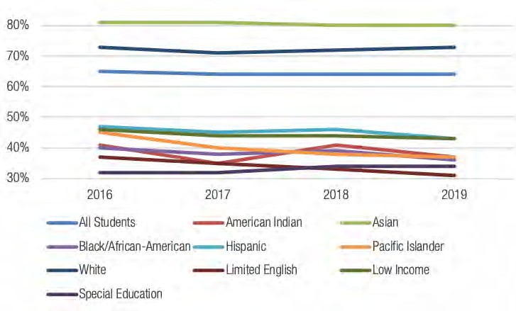

Percentage of students meeting standard in third-grade math (PSESD region)

Smarter Balanced Assessment Results
Source: washingtonstatereportcard.ospi.k12.wa.us

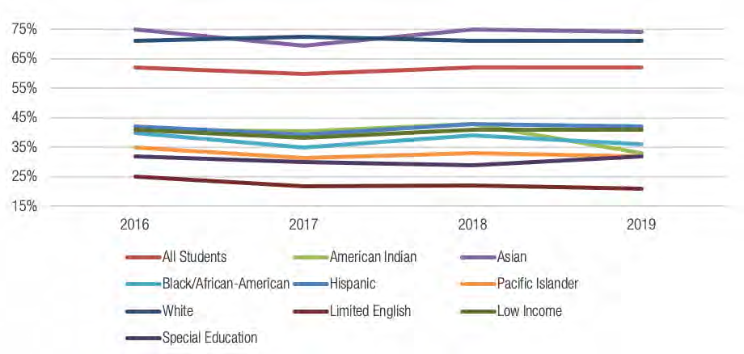

Percentage of students meeting standard in third-grade reading
(PSESD region)

Smarter Balanced Assessment Results
Source: washingtonstatereportcard.ospi.k12.wa.us/

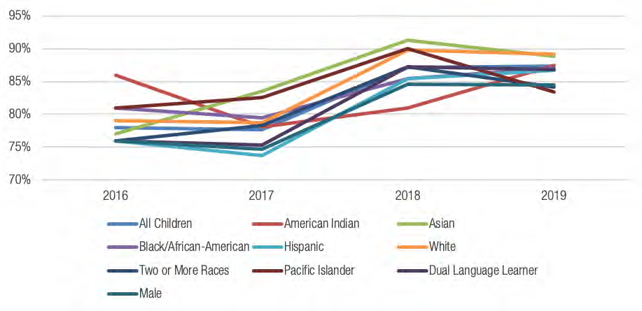
Percent of children meeting school readiness standards (PSESD region)

Teaching Strategies GOLD Assessment Results
Results reflective of preschool children enrolled in PSESD Early Leaning Program in King/Pierce counties Source: PSESD Early Learning Program

Native American Education Program
Measure: Students experiencing a racially just and humanizing school system

The PSESD Native American Education Program (NAEP) provides cultural and educational support to students with Native American heritage. Currently serving more than six hundred students, the program comprises the Pierce County school districts of Franklin Pierce, University Place, Peninsula, and Sumner.

The NAEP service model includes small group visits with students in their schools during the school day to learn and talk about Native history, contemporary issues, and culture as well as what that looks like and feels like for our current Native youth. Staff work with high school students on college and career readiness, graduation support, finding scholarships, and providing letters of recommendations.

“Being in an urban setting, many of our Native students don’t have as many opportunities to make many cultural connections in school. This program is their opportunity to connect with and learn about Native American history and culture and help them find their place in it in the year 2019,” says Jason LaFontaine, NAEP’s Program Manager and an enrolled member of the Turtle Mountain Band of Chippewa tribe.

LaFontaine and his team meet up to two times monthly with students to discuss issues related to their Native American heritage, including contemporary issues, like what
does sovereignty mean and what does it mean to be a self-governing nation; the Civil Rights era of the late 1960s and early 1970s, such as the Fish Wars in the 1970s; and
historical topics from pre-Columbus through the 1700s.

The NAEP team consistently visits forty-two schools collectively each month to talk with students, making it easier for them to participate in the program while also providing
a Native presence on campus. “It’s important for students both in and out of the program to see us in their schools on a regular basis,” says LaFontaine. “We serve as Native
American role models for some students, and are possibly the only Native educator they’ll ever have. Working with groups of students consistently they quickly learn who else
in their school is Native and they realize they’re not alone.”

In addition to building relationships with Native students, the NAEP engages with educators and leaders at the school and district level, providing everything from data on
students in their district to deeper dives into the complexity of the portrayal of Native stereotypes in books commonly used in their curriculum. “Being on-site consistently,
school staff start to recognize us, the kids, and the program itself,” says LaFontaine. “We work with the counselors, showing them the list of Native kids in their school, and
offering our services should those students need extra counseling or support using a cultural lens.”

As a region, we’re fortunate enough to be in an area with an active Native culture, including frequent powwows and the local Puyallup Tribe youth center. Capitalizing on these
resources, NAEP offers a regular schedule of out-of-school activities for participants, families, and communities. “It’s great to show the overall community that we are still
here, we are still active, we are among you,” says LaFontaine. Program events include:

- Family nights focusing on a different craft every month, with parents leading the activity. Native guest speakers are also invited from time to time to share stories, art, and traditional tea-making, for example.
- Powwow dance lessons where kids learn the various dances and regalia worn at such events.
- A field trip to the Puyallup tribe’s Native teaching day, which allowed kids to cycle through seven activity stations. “The kids rotated around, made art, made hand drums—they got to actually be Native,” says LaFontaine.
- Tours of college campuses, filled with discussions about the first-generation Native college experience. According to LaFontaine, “For kids in the program, we provide letters of reference and even offer merit awards to college-goers.”

Walking in two worlds
Finding your Native identity while growing up in a large city or urban area can be a struggle. The NAEP team doesn’t shy away from discussing assimilation.

“We talk about what it means to be assimilated,” says LaFontaine. “It means to connect with dominant culture, to suppress the practice and display of your Native culture, to blend into the world around you, and to play into stereotypes that genericize Native heritage. Then I show students pictures that express our differences—that we’re not only in teepees but also in wigwams, igloos, long-houses; that we dress differently based on climate. I’m illustrating that not all Indians are the same.”

“My colleagues and I often do what I call ‘walking in two worlds,’” says LaFontaine. “We work in school districts that tend to be white dominant and very structured to western
educational practices. We also work with Native educators, elders, artists, and storytellers. We bring in parents who have such rich knowledge to share with all of us. My job is to try and bring all of that together to support Native student success. I want my students to know that they don’t need to leave their culture at the door when they enter the classroom,” LaFontaine said. “Being a bi-racial student a long time ago in the Seattle School District, where no one knew I was Native except my good friends, I want these kids to know there is at least one person in the school that understands what they might be going through. It can be hard to connect to your culture living in an urban area and when you are one of maybe twenty Native students at a school of six hundred. When many of our Native youth
are also more than one race and don’t necessarily ‘look’ like what many non-Natives think a Native American looks like, they can be even more invisible.”

As a result, the NAEP team gets frequent emails from parents that express how students are internalizing what they learn and are excited to continue exploring Native culture more deeply. While this may not be a quantifiable metric, it still connotes the powerful impact of the program on Native students in public schools.

“I’m excited to see their growth, their pride in their culture and identity,” says LaFontaine. “The kids themselves have become advocates for their own heritage, which is the
goal of the program.”

Looking forward
Next year the NAEP will continue building relationships and strengthening communications with the districts it serves. LaFontaine is particularly excited about looking at STEM through a Native lens, considering topics like how the culture survived, how tribes leverage technology, and the role science plays in preserving Native culture.

Parents or guardians can contact the program leaders to register their child for the NAEP via the program page on the PSESD website.

Educational Advocates
Measure: Students experiencing a racially just and humanizing school system

The Student Assistance Educational Advocate (EA) Program helps teens and families involved with juvenile justice navigate re-entry into the education system, obtain community
services, and develop in students the social and academic skills they need to thrive in school and life.

Arthur Dennis, director of PSESD’s Dropout Prevention and Re- Engagement Program, leads educational advocacy efforts in King and Pierce counties. His team provides paroled,
previously incarcerated students ages 13–21 with transitional support as they rejoin a school setting, with the dual goals of preventing recidivism and ensuring they graduate from high school and move on to post-secondary education. Closing gaps to create the conditions for success.

Planning for success involves identifying and closing the gaps in a teen’s support system both inside and outside of school. One of the best ways to identify those gaps is to speak
to the students themselves. “In my most recent visit with incarcerated youth, I spoke with students who are about to be released into the re- entry program,” says Dennis. “I asked
them what they most need, and they answered that they need someone in their life they can trust who can help them make good decisions.”

Advocates work one-on-one with incarcerated youth to set an individual success plan, get school district support for their academic strategy, and address the issues keeping students at risk for recidivism. This work can include:

- Consulting with parents, school staff, and juvenile justice personnel
- Obtaining translation services
- Assisting students in securing birth certificates and Social Security cards
- Hosting skill-building and career exploration sessions
- Coordinating with mental health and housing services
- Supporting enrollment in a school, college, or vocational program

Dennis adds that there’s also no single success story that stands out: “Every kid who gets out of the juvenile justice system and enters their community ready to succeed and
contribute is a success.”

“When you work with incarcerated students, you stare the opportunity gap in the face,” adds Dennis. “We’re always looking at new ways to serve a diverse population of students
with varying learning needs, because there’s no one solution. Students learn differently and we need to continue promoting a system that has the right pathways for kids.”

Community Perspective: Educational Advocates
As told by Alex’s mom, Khristina

Alex was a high-scoring, studious eighth-grader when he was incarcerated, and it set him back academically—he went from eighth-grade honors classes to classes where some students were reading at a third- grade level. While it appeared he was excelling, it was because expectations were set so low.

He was paroled just before the start of high school, when expectations jump. Because he missed a big chunk of his last year of middle school, as well as that all-important transition time, his performance suffered. To see a kid go from As and Bs to barely passing classes, it was a struggle for me. I didn’t know what was going on.

It was so beneficial to us to have Lane Krumpos, our educational advocate, on our side. Lane is another adult in Alex’s life who’s on his side, holding him accountable; another person who sees what he’s capable of, who cares about him. She helped him in ways that parents and schools can’t.

Lane helped us navigate the landscape, giving us her honest take on what was reasonable and what was not. She served as a sanity check for me as well as a go-between for Alex, me, and the school system.

Lane deals with paroled kids all day long, which means she’s not only knowledgeable but also patient, kind, and empathetic. She’s also not his parent—she looks at things a different way and has a different toolbox than I do. She helped Alex identify the structures and supports he needed to be successful.

As a result, he passed all his classes at the end of the year. He’s now entering his junior year and getting ready for the Running Start program. He plans to graduate high school with his associate’s degree. Without Lane’s help I don’t think he’d be prepared to enter that.

There’s so much prejudice against these kids—people assume they’re troublemakers, disruptors, that they need to follow stringent rules and restrictions, that there are all these things they shouldn’t be allowed to do. When we were told we’d be getting an advocate I wasn’t sure what to expect. I thought it was someone from the school who’d follow Alex around and be sure he’s doing what he’s supposed to be doing—yet another person we’d have to report to. By the end of our first two months together, that’s not how I looked at it anymore. She’s a help, not a hindrance.

Lane gave us the help we needed that we didn’t know we needed. I wish every kid, regardless of their situation, was able to have an advocate who isn’t their parents to hold them and their school accountable, and I hope every family knows this is available and utilizes it as extra help.

Looking forward
EA’s primary goal remains consistent: To continue working with students who haven’t yet had the opportunity to graduate. However, the team is also working on prevention
strategies, partnering with OSPI to define what it means to be at risk, identifying at-risk students, then doing preventative outreach and recruitment.

One vector for risk is chronic absenteeism and truancy. “School disengagement can be a predictive indicator—if you’re not in school, you may be promoting violence in the community because you’re living outside the norms, you’re not having positive experiences, and you’re not planning for post-secondary life,” says Dennis. “Ideally we want to identify and start working with these kids before they’re ever incarcerated.”

Educational Advocate services are free to students, parents, schools and juvenile justice staff in participating agencies. Referred students must be returning to King or Pierce County from a DSHS Juvenile Rehabilitation Institution or be involved with Pierce County Juvenile Court. For more information, visit PSESD’s Dropout Prevention and Re-Engagement page.

SYSTEMS MEASURES OF PROGRESS

Regional Executive Discipline Group
Measure: Exclusionary discipline rates

The Regional Executive Discipline Group (REDG) helps school systems understand and take action on new state legislation around discipline, practices, and policies. The group
supports districts’ efforts to streamline and put in place solid technical tools for complying with the new law, while ensuring equity in matters of discipline, focusing not on
deficits but on assets and positive outcomes.

REDG members represent a cross-section of the community, including an outside attorney, a representative from OSPI and the Association of Washington School Principals, as well as school leaders who are often on the front lines of discipline. The goal of the group is to establish common language, norms, and definitions, and then for group members to share that with their constituents so that everyone understands the disciplinary system, as well as the connection between equity and discipline.

“Discipline is a sensitive topic, and if it’s not done right, it can cost districts significantly,” says Brad Brown, LTFS Executive Director. “We need to be speaking the same language
and we need to be solutions-driven. We realized we could use these new compliance standards as a container to grow some adaptive changes, and to do it with an equity lens.”

Acting under the principle that all students want to learn and be successful, the REDG discusses how adults can affect changes in classroom climate. They look at different practices across the region, share out what’s working, and work to create a balance in voice and opportunity.

Racial equity and disproportionate discipline
Disciplinary action is often subjective, and root-cause analyses reveal that the severity of discipline often falls along racial lines. The discipline gap impacts students in profound
ways. When one student is treated differently from another student who behaves the same way, it can cause negative repercussions throughout life.

“When we look at students who’ve been sent out for ‘disruption’ or ‘minor classroom or school rule violations,’ we find that they are disproportionately students of color,” says Brown. “At that point there’s a tendency to translate ‘disruption’ into ‘disrespect.’ Girls of color are often seen as being ‘disrespectful,’ which is more egregious sounding than ‘disruptive’ and stirs up stereotypes, preventing educators from viewing that student as someone who may feel voiceless. As a result, the student "is left feeling teachers don’t believe in them, which creates a downward spiral of lower self-expectations, and lower teacher expectations for that student.”

While districts have done a better job of lowering suspension rates, there is still an over-representation of students of color. “Looking at the data, we see that a small number of students are being suspended a large amount of the time,” says Brown. “And every minute of suspension is a minute of instructional time lost. Better data systems and better tracking—which the REDG is working to create—will help schools be more observant of these disparities.”

Discipline prevention
“When a student has purpose and direction, they’re less likely to act out. There’s an opportunity at the pre-discipline and early discipline stages to promote in those students goal oriented thinking; to give them a sense of purpose,” says Brown.

The law helps hold districts accountable for being proactive about reducing lost instruction time and demographic imbalance. After REDG gatherings, members return to their organizations and school systems ready to model and message effectively to their colleagues about the connection between reducing discipline time and increasing graduation rates.

As an example, this year the REDG established a behavior agreement with students, a peer program so that students can get extra support from kids their own age, and several common forms that help school systems assess the resources that already exist within their buildings.

“Career counselors, after-school coordinators, attendance clerks—everyone
plays a role in supporting students’ mental health and well-being,” says Brown. “Our group reflects on how they’re using their resources, and examines whether those resources amplify problems rather than improve systems and situations.”

Looking forward
During the 2019–2020 school year, the REDG plans to more deeply involve community members as well as educators. The group’s goals include:

- Coming to a common understanding of the technical aspects of the law
- Continuing to create common disciplinary forms
- Creating true, authentic partnerships
- Bringing in unique perspectives and voices
- Understanding the lived experience of English learners to better serve students and their communities

“School climate changes when people are working toward a shared goal, feel their voices and opinions are being heard and respected, and when people feel empowered to own
their part of the change process,” says Brown. “Ultimately we want to shift focus to the human side of discipline prevention—getting adults to believe that all students can, and want, to learn.”

For more information or to join the group, contact Brad Brown at bbbrown@psesd.org.

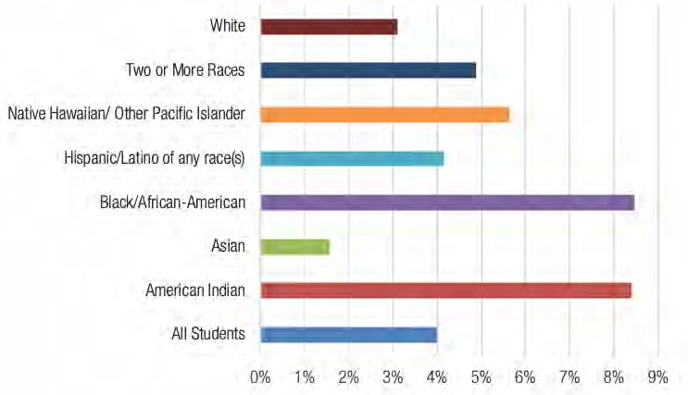

Discipline rate by student demographics (WA state)
What percent of students are excluded in response to a behavioral violation by student demographics?

Note: Discipline rate is a measure used to monitor the use of out-of-school exclusionary discipline actions in schools. Discipline Rate is calculated by counting the number of distinct students who have received an out-of-school exclusionary action divided by the number of distinct students enrolled. For the purposes of this calculation, out-of-school exclusionary actions include: Short-term Suspension (SS), Long-term Suspension (LS), Emergency Expulsion (EE), and Expulsion (EX). The number of distinct students enrolled includes students enrolled at any point during the school year regardless of the length of enrollment.
Source: OSPI Report Card

Expanded Learning
Measure: Opportunities for prosocial school involvement; sixth-grade student commitment to school

PSESD offers Expanded Learning opportunities for children in a supervised, safe, and drug-free environment. Opportunities are intentionally aligned with the content standards students learn in school, providing students and families with experiences outside the classroom that accelerate academic success, increase social-emotional growth, and develop meaningful community connections.

Expanded Learning is a collaborative effort between the ESD, school systems, families, and community partners to meet students where they are. Programs are delivered by teachers, paraeducators, community organizations, and PSESD direct service staff, and each site has its own coordinator. These programs offer students many benefits:

Academic
- Review the math and reading skills they honed in class
- Get extra time and support to complete schoolwork

Social
- Collaborate on activities in small groups with new peers
- Develop social-emotional, relationship, and life skills

Experiential
- Gain exposure to new and varied cultures
- Participate in enrichment projects and excursions

Liz Chick, the Director of PSESD’s Expanded Learning Program, works with school and community partners to connect the dots so that schools can begin and sustain successful after-school programs, focusing on elementary and middle schools that need support in math or reading, have a high percentage of students in the free/reduced lunch program, and have a highly diverse population.

“Expanded Learning is all about building relationships with students—getting to know them, being there for them when they struggle, making them feel valued and supported,
and then building academic capabilities based on that solid foundation of trust,” says Chick. “It’s the winning recipe for prosocial behavior, when the real magic happens, and it
leads to lower disciplinary actions as well as improved teacher and student experiences.”

Meeting the needs of the community
Expanded Learning is most successful and enriching when it pulls together multiple partners to address the needs of a community’s students, and to meet students where they are. “It’s a win-win—organizations offer their services, and students benefit without having to overcome barriers like transportation and scheduling,” says Chick. Examples of past partnerships include:

- A city parks and recreation department facilitating sports and outdoor activities in neighborhood schools
- A foundation working with refugee students in a district
- A community center in a mobile home park hosting a “know your rights” seminar, conducted in Spanish by Latinx presenters

In addition, Expanded Learning teams partner with families to strengthen the school-home connection. “Parents want to feel involved and advocate for their child’s education, but transportation and timing are significant barriers. Coming to parents is really key. We put ourselves into the community, going as far as to host events in apartment complexes where many students live,” says Chick. “We make the timing flexible, offer lots of heads-up, make direct phone calls to promote the event, and we feature success stories from local students in the Expanded Learning Program.”

Lastly, Expanded Learning teams partner with individual schools to ensure a cultural fit. Expanded Learning coordinators are on-site in school buildings, walking the hallways and making themselves available to both students and teachers during lunch hours and recess. During after-school programs, they have the time for meaning conversations. Keeping open communications channels between expanded learning coordinators and school staff brings a student’s total support system into the loop.

Partnership in action: PSESD and the Environmental Science Center
In partnership with Burien’s Environmental Science Center, students and teachers in Expanded Learning programs across Puyallup, Bethel, Franklin Pierce, Tacoma, and Kent school districts explored biomimicry, a problem-solving approach that looks to nature for possible solutions to a human problem. For example, students worked to optimize the power of a windmill by studying the shape of a whale’s fn. Middle schoolers did more independent work, determining the human problem themselves and then looking for solutions in nature. It fostered teamwork, empathy, and connection to life outside of school.

Partnership in action: PSESD and Kent School District
One of the aims of the Expanded Learning Program is academic achievement. Kent School District set an Expanded Learning goal for its Mill Creek and Meeker Middle Schools: to increase student achievement in reading and math by getting at least 50% of regularly attending students improve reading and math scores by 50%. PSESD helped the district create “scholar hour, an Expanded Learning program wherein students can get the extra teacher support they need in a small-group setting. As a result, reading and math scores exceeded expectations: 55% of students improved in reading, and 72% improved in math.

Student Perspectives on Expanded Learning
Middle school students in the Meeker Afterschool Program (Kent School District)

“The best part about being in the summer camp program was being able to try out different types of art activities like painting and DIY soap making. I also liked being able to see SubZero Ice Cream, to visit and learn about his business and how he uses nitrogen and science to make his ice cream. Being able to see him make ice cream for the whole group was fun, too! I liked being able to hang out and do art activities.”

“I enjoyed being able to learn about leadership and teamwork through our morning activity challenges like the ‘egg drop’ and ‘marshmallow tower. These challenges taught me how to build my leadership while working with my team, staff, and others. I also enjoyed our visit to the University of Washington in Seattle to tour the campus. I learned about the different education fields offered on campus, activities college students can participate in, and about the different types of financial aid scholarships and grants available that could help me get into college.”

“I enjoyed the summer camp because of the variety of fun activities we were able to do. I also enjoyed being able to meet a few of the new students coming to Meeker this school year. I was able to start forming friendships with staff and new friends I met during the summer. I also got to see and learn about the school before the school year started, touring the school, finding out where my classes might be located, and meeting some of the school-day teachers. I also really enjoyed being able to go on the Everett Aquasox field trip and run on the field with the baseball players as part of their opening ceremony.”

“I liked working with all the teachers and after school staff, having a safe but really fun place for kids to go to and have fun doing various art activities and getting help during academic hour. I also liked going on the CEO Boss Life [career education] field trips and getting to meet the owners and players of the Seattle Storm basketball team.”

“The after-school program was fun because all of the teachers were very nice and supportive when I was having a bad day in class or at home. During that time, it was difficult for me to speak with others about how I was feeling and I would be upset with everyone. The staff taught me how to be more communicative to let others know how I am feeling and when I need support.”

Looking forward
Expanded Learning is hoping to grow its partnerships in the year ahead. “My hope is that all schools have free expanded learning opportunities for their students,” says Chick. “A lot of out-of-school activities cost money, and not all families have the room in their budgets. That creates an experience and opportunity gap for our kids; free Expanded Learning can close that gap.”

To learn more about expanded learning programs, visit PSESD’s Expanded Learning page.

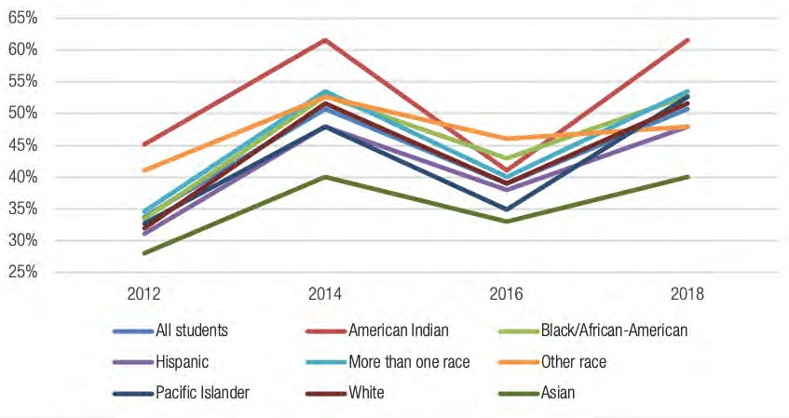

Percent of students at risk of low commitment to school (PSESD region)

Healthy Youth Survey Results: Low Commitment to School, Grade 6
Source: Susan Richardson, Healthy Youth Survey

Note: Results should be interpreted with caution, and with confidence intervals in mind.

Race | % at Risk with Confidence Interval |  |  | N
All 6th graders | 50.7% | ± | 2.7 | 4773
American Indian | 61.6% | ± | 10.8 | 217
Asian | 40.1% | ± | 6.7 | 455
Black/African-American | 52.8% | ± | 6.5 | 292
Hispanic | 47.9% | ± | 6.7 | 487
More than one race | 53.5% | ± | 4.1 | 497
Native Hawaiian/Pacific Islander | 48.0% | ± | 9.8 | 131
Other race | 52.7% | ± | 4.9 | 833
White | 51.6% | ± | 3.5 | 1614

.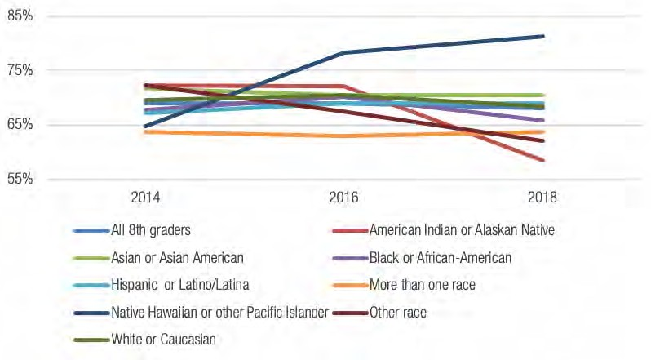

Protective factor: Opportunities for students to have prosocial involvement in school (PSESD region)

Healthy Youth Survey Results: Grade 8
Source: AskHYS.net, Healthy Youth Survey

Note: Results should be interpreted with caution, and with confidence intervals in mind.
Race | % with High Protection Confidence Interval |  |  | N
All 8th graders | 67.6% | ± | 3.2 | 3598
American Indian or Alaskan Native | 58.4% | ± | 12.7 | 77
Asian or Asian American | 70.4% | ± | 3.7 | 460
Black or African-American | 65.8% | ± | 5.7 | 263
Hispanic or Latinx | 68.9% | ± | 6.4 | 379
More than one race | 63.7% | ± | 7.2 | 397
Native Hawaiian or Pacific Islander | 81.2% | ± | 8.2 | 85
Other race | 62.0% | ± | 4.4 | 313
White | 68.4% | ± | 3.6 | 1557

Workers' Compensation Trust and Unemployment Pool
Measure: School district financial health

In Washington, businesses must insure their staff against on-the-job injuries. To minimize the total cost of workers’ compensation risk, PSESD has formed a Workers’ Compensation Trust (WCT), which acts as a third-party provider offering group rates for covering on-the-job-injuries.

The WCT is a self-insured pool for workers’ compensation coverage. It provides insurance for on-the-job injuries for thirty-four school districts and their forty-five thousand employees in King, Pierce, Skagit, Snohomish, and Whatcom counties. WCT staff work with the employer to assess workplace safety and implement effective loss control programs, while ESDs receive professional claims management services to help injured workers return to the workplace.

The goal of the WCT is to minimize a district’s cost of risk, saving districts money and allows school systems to invest more in students, educators and school staff. “This is how we align with the ESD’s goal of success for each child and closing the opportunity gap by leading with racial equity,” says Clairmonte Cappelle, WCT’s Executive Director.

Employees across the WCT’s thirty-four member districts log fifty-fve million worker hours annually—it is the largest program of its kind in the state. With that level of
responsibility, and keeping equity in mind, WCT has taken additional measures to help its members prevent injury and help an employee return to work as quickly as possible. Its
approach is twofold:

- Work with schools to make sure the sites are safe for all staff
- Manage claims assertively and expediently, minimizing the cost of replacement staff and wage loss

Bringing cultural relevance to claims and loss control
WCT has given careful consideration to weaving equity into its claims management and safety training processes. “Three years ago we implemented a new claims management
system that voluntarily collects heritage information,” says Cappelle. “This gives us an idea of an employee’s preferred language of communication, as well as their preferred
communications channel. With that information, we can plan, for example, to have translators who join in on phone calls with employees who prefer to have phone conversations in Spanish.”

On the loss-control side, WCT endeavors to work with school districts to ensure safety protocols and trainings are conducted in a language employees can understand. “If they
understand, they are less likely to get injured,” says Cappelle.

Incentivizing savings
The Return to Work (RtW) Program brings back to work employees who are too injured to perform their day-to-day job but are able to do an alternative job. For example, an injured custodian can’t lift heavy things, but their role can be modified to not lift above a safe weight. RtW also coordinates with supervisors to ensure teams can fill the gaps left by an injured worker’s transitional role.

Schools in the RtW Program get reimbursed for employing someone in a transitional role, and the fund is equitable from a district-size perspective. Rather than calculating the range of fund draws based on worker hours, which is the standard metric used to normalize activity or measure outcomes among school districts (which would negatively affect smaller school districts), the RtW set a standard range of fund draws for all districts.

“Out on their own, districts pay more,” says Cappelle. “In a pool like ours, districts pay less, especially if they also implement reduction strategies and participate in the RtW Program. “We contribute to a district’s financial health, and every dollar saved is a dollar spent on students."

Looking forward
Next fiscal year, WCT will shift its focus to the injured worker’s personal experience. “We developed a survey that will go to injured workers so that we can gauge their satisfaction with our services and our vendor partners,” says Cappelle.

Districts outside the PSESD region can also participate in the WCT. For more information on participation, and to learn about the unemployment pool, another offering from the WCT team, visit their website.

AGENCY MEASURES OF PROGRESS

Puget Sound College & Career Network: Working with Partners to Share and Scale Gap-Closing Practices

Measure: High school graduation rate; postsecondary direct enrollment; percent of students enrolled in pre-college courses in math in two-year colleges; postsecondary completion

Nearly every student in South King County’s Road Map region (the Auburn, Federal Way, Highline, Kent, Renton, Seattle and Tukwila school districts) wants to obtain at least some college degree. Yet despite these aspirations, only 59% of Road Map graduates enroll directly in college, and college completion rates hover around 30%.

In autumn 2018 the Community Center for Education Results (CCER) published "To and Through: Community and Technical Colleges in South Seattle and South King County." The report analyzed technical college data in the region, following students from ninth grade through postsecondary schooling to identify barriers they encountered along the way. The data revealed pre-college (commonly called “remedial”) course requirements as a significant barrier to both college entry and postsecondary completion. Furthermore, it showed that black and brown students are disproportionately placed in pre-college courses.

“This is a racial equity issue. We’re putting up barriers for students and hampering postsecondary completion,” says Kyla Lackie, Director of Postsecondary Programs at PSESD.

How does a student get placed in pre-college courses?
Course placement is a critical part of students feeling they belong on campus. Placement can be based on a student’s high school transcript, which is a strong predictor of future performance, however the burden is on students to get those documents.

“It’s not as easy as it sounds,” says Lackie. “Sometimes school is closed; sometimes students are required to pay three dollars in cash, on-site. It’s particularly confusing for students who’ve already graduated.”

In lieu of a transcript, a student must take a placement exam. While these exams are a convenient option for colleges, most students are underprepared to take the test—they arrive to register for courses, and end up taking a test they didn’t study for, whose academic and financial stakes they don’t understand.

“Based on statistics on missed placement, we know that if we’d placed certain students based on a test score they would have landed in pre-college courses, but placing them based on transcripts they could have enrolled in a for-credit course. Placement exams lead to misplacement; that’s where it becomes unavoidable as an equity gap,” says Lackie.

To lead with racial equity, Highline College introduces multiple measures
To address these inequities, Highline College changed its practices around placement, giving students more agency in the placement process as well as more information and support for getting placed accurately, and using multiple measures like transcripts and overall GPA.

The college also began offering self-directed placement, wherein students are counseled through the placement process and encouraged to select pre-college or for-credit courses. Lastly, should students need to take the placement test, Highline started offering preparatory workshops and allowing students to take the test multiple times.

“We wanted to put students at the center of what is a critically important decision in their educational career,” says Shannon Waits of Highline College. “It’s about informing them about the stakes of math placement, making sure they know what they need to earn their degree, and giving them the resources they need to be successful should they have to take the test.”

Results
Before moving to multiple measures, in 2014 only 17% of students placed into college math. By 2017, 63% of students placed into college-level math, and Highline noted no significant difference in course grades based on placement measure.

“The test has been under-placing students and depriving them of college courses,” says Waits. “Transcripts are a barrier reducer and a more accurate predictor of success because they’re placing students in the course they’re ready for, rather than under-placing them. With the use of transcripts, more students of color gain access to college-level courses.”

Ethnicity: White
Placed in college-level math via placement test: 33%
Placed in college-level math via multiple measures: 64%

Ethnicity: Black
Placed in college-level math via placement test: 32%
Placed in college-level math via multiple measures: 47%

Ethnicity: Latinx
Placed in college-level math via placement test: 13%
Placed in college-level math via multiple measures: 49%

PSESD collaborates with partners to amplify and scale gap-closing practices
Inequity in college placement is a complex, long-standing issue that sits at the intersection between K–12 and higher ed, requiring cross- system engagement between partners who play many roles within those systems.

PSESD acts as a connector between technical colleges, districts, parents, students, and
community organizations. The agency identifies opportunities and holds space for cross-
collaboration, raises questions about what we can do locally to create positive change, and
amplifies what practices are working. “We have a lot of control within our local region to
better collaborate, communicate, and connect,” says Lackie. Highline’s work has affected
other colleges in the region. “We have impact data that shows the benefits of multiple
measures, and of turning the placement into an education experience, rather than a transactional experience,” says Waits, who recently worked with seventeen colleges across
the state on a year-long project to move toward multiple measures.

In addition to serving as an amplifier, the Puget Sound College and Career Network, an effort of PSESD, has secured a grant to study the longitudinal impact of Highline’s math
placement practices, from admission through post-secondary completion.

Looking Forward
“Now we’re looking at how completion rates have changed,” says Waits. “We know that math is one of those requirements students are missing even though they’re otherwise ready to graduate. If they place in college-level math, they’re more likely to finish their degree.”

A future study will center around the student experience of getting placed and making the transition from high school to college, but anecdotal data is promising. “We’ve already heard that more students feel they are in the right math class, and more students feel confident they can succeed in math.”

“Our job is to keep the pressure and priority on,” says Lackie. “Colleges claim they use multiple measures, but we don’t have hard data on how many students get placed based on transcripts, tests, and/or self-placement—we don’t even know the baseline. So part of our work is to continue raising the question, to create a collective vision regionally about what placement looks like for our students who are direct enrolling. We have leaders who are ready to lead this work, and educators who see the disparities and the potential for changing the placement experience. I think it’s possible for us regionally to transform what placement looks like for students, which in turn can transform the completion outcomes we’re seeing for students.”

The Puget Sound College and Career Network partners with local colleges, school districts, and community organizations to encourage more use of high school transcripts to increase student success at community and technical colleges. To learn more, visit their website.

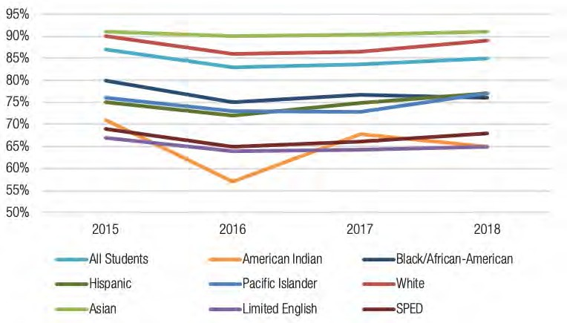

Students graduating high school: 5-year graduation rate (PSESD region)

Source: OSPI Report Card

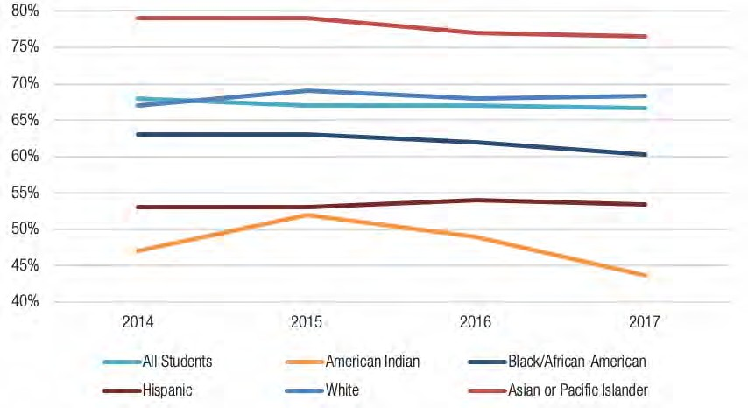

Students enrolled in postsecondary education (PSESD region)

Source: OSPI Report Card
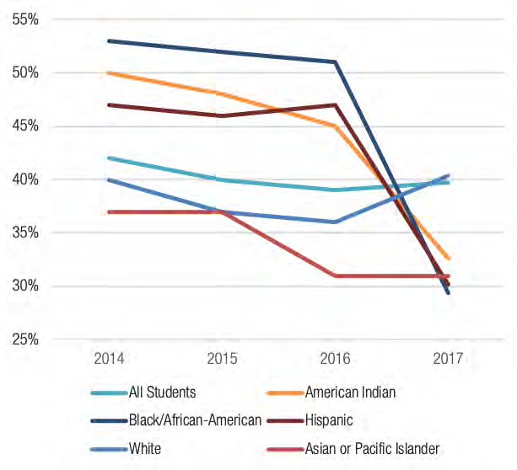

Students enrolled in pre-college courses in math in two-year colleges (PSESD region)

Note: ERDC reports some data using percentage widths (e.g. 40-44%). This 1) Prevents the accidental disclosure of student-level information and 2) conveys that the precision of rates for smaller schools or districts is lower than the precision of rates for schools or districts with larger numbers of graduates (erdcdata.wa.gov/FAQ.pdf). The upper limit of the percentage width is used in this chart.
Source: OSPI Report Card

All
Female Male
American Indian or Alas..
Asian Black or African Americ.. Multiple Races (Details .. Native Hawaiian and Ot.. Spanish/Hispanic/Latino
White
>=3.0
<3.0
FRPL Not FRPL
Special Education Not Special Education
Bilingual Not Bilingual Section 504
Not Section 504

0% 40% 80% 0% 40% 80% 0% 40% 80%
% Enrolled % Enrolled % Enrolled

Note: These are statewide results. PSESD-level results are not yet available.
Source: erdc.wa.gov/data-dashboards/high-school-graduate-outcomes
2-Year / CTC Not Enrolled
4-Year
What is the highest postsecondary credential earned within 8 years of high school graduation? (WA state)

Leadership Development and Evaluation Pilot
Measure: PSESD staff growing in their racial equity leadership; retention of a diverse workforce in K–12

As part of implementing PSESD’s racial equity plan, which includes the goal of eliminating barriers in hiring and retention of a diverse workforce, PSESD is piloting a new system for developing and evaluating leaders based on agency-wide competencies around racial equity.

The Leadership Development and Evaluation pilot primarily focuses on cultivating a diverse workforce through equitable systems and practices. It aims to grow equity leadership in four domains: cultural proficiency, racial equity mindset, racial equity advocacy, and transformational values.

“Our HR department doesn’t have direct access to children or students but our staff does, and all the work we do at the ESD contributes to positive student outcomes,” says Denise Altheimer, who serves as Executive Director of Human Resources and Organizational Development for PSESD. “If we do well in our internal work, our partners and community should experience us differently, and outcomes will change.” By supporting our own antiracist leadership development and practices, PSESD supports stronger retention of our own diverse workforce.

“We’re setting up a system for an organization that asks people to think and act
differently, bringing the frame of equity up front,” says Hilary Loeb, PSESD’s Director of
Strategy, Evaluation and Learning.

Adjusting practice to fit departmental and programmatic cultures
The pilot’s larger aim is to create strong supportive relationships between managers and employees, and for employees to reflect on antiracist practices brought to life in the
competencies. In different departments, this shows up in different ways.

“We’ve had conversations with the early learning team, who support a system of direct services to students and families,” says Loeb. “It’s on-the-ground community work; staff will need to think about how they’re supporting equity-focused practices with children and parents. On the other hand, the Workers’ Compensation Trust is looking at upstream and downstream solutions that focus on worker safety, including translation services for employees whose first language isn’t English. These two programs envision equity in their work in different ways, and both have different norms around behavior, communications, and relationships.”

“We’ve learned from staff in indirect programs that finding the correlation between what they do and the competencies requires stronger intentionality on our part,” says

About the pilot
An implementation team, called Strategic Direction Action Team 2, partnered with human resources to codesign the system, practices, and policies, identifying and focusing on ways to reach out to the community as well as supporting the staff to lead with equity.

The pilot included the superintendent’s office; the leadership staff of the early learning department, the Workers’ Compensation Trust and risk management pool; human resources; and all members of Strategic Direction Action Team 2.

After a year of seminars and coaching sessions the pilot culminated in focus groups where participants WSRMP direct report reflected on ways they can integrate their learnings into their day-to-day work. These insights shape the plan for the year ahead.

Looking forward
In September 2019 the pilot expanded agency-wide, incorporating focus group feedback from the past year’s participants, including how to scale a new performance management system to the entire organization. By the end of the 2019– 2020 school year, the goal is to have a fully refined system for leadership development and evaluation.

“This is an ambitious rollout and we need to bring our best selves to the work, because our work presents a starting point for changing larger processes,” says Altheimer. “We are always learning, testing, examining, reflecting, and evaluating. I believe we are on the right path to answering the questions ‘How do I develop myself as an antiracist leader?’ and ‘How does that development benefit others?’ Awareness-raising opens our eyes to the things we take for granted, but really to lead with racial equity you have to have intentionality around it. As one of our colleagues consistently points out, the ‘s’ in ESD is for service, both to self and to others.”

For more information on the pilot, contact Denise Altheimer at daltheimer@psesd.org.

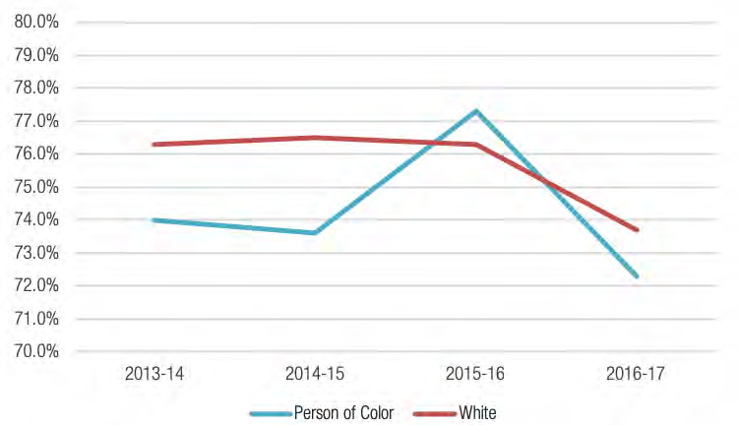
Retention of a Diverse Workforce (K–12 certificated and classified educators)

Note: Methodology data for the Retention of a Diverse Workforce can be reviewed at pesb.wa.gov.
Source: Professional Educator Standards Board

Racial Equity Training with Early Learning Providers
Measure: PSESD supports external partners to build skill and will for change and/or adopt a racial equity lens

PSESD's Early Learning program includes federally funded Head Start and Early Head Start and the state-funded Early Childhood Education and Assistance Program (ECEAP), and serves approximately five thousand early learners and their families across the Puget Sound region. In addition, the ESD operates its own early learning centers and subcontracts to support early learning centers participating in Early Head Start, Head Start, and ECEAP throughout King and Pierce counties.

The Early Learning department offers racial equity training to Head Start/Early Head Start/ECEAP Policy Council parents, parent ambassadors, peer programs, ESD early
learning staff, and forty-three early learning partners comprising school districts, child-care centers, community colleges, family child-care providers, and community agencies.
Offerings include overview sessions, half-day deep dives, multi-day trainings, and seminar series that span across months, and trainings are tailored to each partner’s priorities, as well as where they are on their own equity journey.

“The Early Learning team has a long-standing goal of making sure we apply a racial equity lens internally and externally, supporting our sites and centers as they support children of families of color,” says Kay Lancaster, Executive Director of Early Learning. “We want our partners to align with our mission and goals as an agency, and we allocate resources to ensure this happens.” Why address race in early learning? Adults often wonder at what age kids are old enough to talk about race, but the research says infants can differentiate based on skin color. As a result, it’s important to start with infants, toddlers, and preschoolers. Children are always learning, and to have an impact on that we must acknowledge that they learn based on what and how adults interact with each other.

“Kids learn from us not talking about it, which means they’re not learning what we want them to learn,” says Lancaster. “They see what we do and don’t do, say and don’t say. Our job as adults is to work on ourselves so that our actions match what we profess our values to be, and to be explicit about that with children.”

Partnership in action
As told by Michelle Morse

“We had an enthusiastic Policy Council parent who loved the racial equity training we provided. He approached us to ask if we could bring the training to his community’s sites and centers. Based on input from parents, we decided to make the workshop about how to talk to kids about race. Family support staff organized the event, and it was a great collaboration. First, one staff member was bilingual and half of workshop participants were Spanish speakers. Second, the center director was inspired to invite us in to train the staff. The goal is to create a shared language mirrored by ESD, sites, centers, preK programs, families, and children—to strengthen bonds and provide a consistent experience, to show that we’re all in this together."

“Aha moments”
Racial equity training is unique; outcomes, progress, and impact look different from other trainings, because it is personal work that happens on each person’s timeline based on past experience and current circumstances.

“One of the teachers who attended our seminar shared that her life changed after an earlier racial equity training,” says Heather Kawamoto, Equity in Education Program Manager. “She saw how much white privilege she and her family had, and she shared a lot of that experience during the seminar. Through the sharing process it was clear that she got it, she understood, she could share with service and support staff how much she’d learned and grown, and how much she’s still growing. It was amazing to hear how much she’d grown on her own as a result of training. It impacted her personal life and her life as a teacher who works with children and families of color.”

Partnership is critical to the success of equity work. Trust among the early learning team, its partners, and the community; building capacity internally and externally; and committing more time to on-site work creates the conditions for magic “aha moments” to happen. Over the past year, the early learning team focused on building internal capacity to facilitate racial equity trainings, which has the compound effect of increasing the number of people they can serve.

“As a facilitator, I love co-creating a container that allows participants to unlearn what they have been socialized to learn, relearn history in a different way, and examine how intentional and strategic institutional racism is,” says Morse. “For white people, this often leads to a lot of internal work: a deep unpacking and examining stories we’ve been told, who we grew up around, how that’s shaped who we are today, and our implicit biases.”

Looking forward
“Roughly a quarter of our forty-three sites and centers have made commitments and scheduled trainings,” says Kawamoto. “With our expanded capacity, we can reach all those who are eager to engage, and we can build racial equity supports for early learning programs in our communities.”

“We’re excited about our expanded capacity and the work that’s been done to engage our community partners,” says Lancaster. “I’m excited to go into next year and leverage
the on-the-ground work our team has done to more deeply engage the community.”

LOOKING FORWARD
This year PSESD determined its student, system, and agency-wide outcomes, as well as measures of progress for many of those outcomes.

As we advance through the 2019–2020 school year, we will move to the second phase of our work, which will be to finalize all our measures of progress and start reporting that data to the community.

We will also continue emphasizing close partnership with those we serve, doing the important work together rather than in isolation. For example, this year our student interns will be co-creating the measures for our outcome of “students experiencing a racially just and humanizing school system.”

This is a baseline year for many of our measures, and we will continue to track and report progress over time. In past years, our measures have been fairly easy to quantify—percentage of students reading on grade level; graduation rates; and so on. Those remain important metrics that we will track and report, and which directly contribute to our outcomes. However, with the adoption of our new measures of progress, some of the data we collect to gauge the impact of our efforts will be more qualitative.

Our goal as an ESD is to be an authentic partner to districts, organizations, and families across the region as we collectively strive to create a racially just and humanizing school system. This work is not an exact science but rather an evolving process; we are all on a continuum of learning, and every aha moment takes us a step further along our path.

We’re eager to hear from you, the community, about how we can support your efforts and advance toward our own outcomes. Please reach out with your ideas, thoughts, and comments at psesd.org/about-psesd/contact- us. In addition, if you’d like to support our work by joining our team, you can review our open positions at psesd.org/careers.

TRANSFORMATION TEAM
The Transformation Team comprises PSESD staff, community members, and parents guiding the implementation of our racial equity policy in order to lead the agency toward becoming an ARMCO.

Abraham Rodriguez Hernandez
Director, Equity in Education

Amy Meiser
Coordinator

Angelica Alvarez
Manager

Anna Wade
Director

Carolyn Solitaire
Community Member

Denise Altheimer
Executive Director

Eileen Yoshina
Director

Felisciana Peralta
Executive Director

Greta Bornemann
Director

Heather Kawamoto
Program Manager

Immaculate Ferreria-Allah
Community Member

Julie Rolling
Executive Director

Lori Pittman
Advisor

Matthew Gulbranson
Director

Maxine Broussard-Upchurch
Director

Michelle Morse
Program Manager

Sarita Siqueiros Thornburg
Executive Director

EXECUTIVE LEADERSHIP TEAM
John P. Welch, Superintendent
John P. Welch was appointed in 2012 as the Superintendent of the Puget Sound Educational Service District. As the agency's Chief Executive Officer, Mr. Welch leads the educational service district serving 428,000 students from preschool through grades 12, across 35 school districts, 8 charter schools, and 2 tribal compact schools in the greater Seattle–Tacoma region of Washington State. The vision of the agency is to ensure success for each child and eliminate the opportunity gap by leading with racial equity.

Previously, Mr. Welch served as the Superintendent of Highline Public Schools and Vice President for Business and Administrative Services for South Seattle College. Mr. Welch holds an MBA from Pacific Lutheran University and a BA in Business Administration from Eastern Washington University. He is a graduate of the Broad Urban Superintendent's Academy and has taken executive development courses at Harvard University, Stanford University and University of Denver.

Denise Altheimer
Executive Director
Human Resources &
Organizational Development

Brad Brown
Executive Director
Learning, Teaching and Family Support

Clairmonte Cappelle
Executive Director
Workers’ Compensation Trust, Unemployment Pool & Technology

Jessica de Barros
Executive Director
Communications, Government and Public Relations

Kay Lancaster
Executive Director
Early Learning, P–Third Grade

Amber McCulloch
Executive Director
K–Postsecondary

Felisciana Peralta
Executive Director
Equity in Education

Julie Rolling
Executive Director
Learning, Teaching and Family Support

Sarita Siqueiros Thornburg
Executive Director
Strategy, Evaluation and Learning

Jolianne Valentino
Executive Director
Business and Operations

BOARD OF DIRECTORS
Jordan Posamentier
District 1
Districts Represented: Shoreline, Seattle (part)

Greg Bawden
District 4
Districts Represented: Lake Washington, Northshore, Riverview, Skykomish

Barbara Peterson
District 7
Districts Represented: Federal Way, Fife, Highline, Tukwila

Annie Laurie Armstrong
District 2
Districts Represented: Bainbridge Island, Vashon Island, Seattle (part)

Agda Burchard
District 5
Districts Represented: Kent, Renton, Seattle (part)

Jill Johnson
District 8
Districts Represented: Peninsula, Tacoma, University Place

Someireh Amirfaiz
District 3
Districts Represented: Issaquah, Bellevue, Mercer Island, Seattle (part)

Joanne Seng
District 6
Districts Represented: Auburn, Dieringer, Enumclaw, Puyallup, Snoqualmie Valley, Sumner-Bonney Lake, Tahoma

John Zurfuh
District 9
Districts Represented: Steilacoom, Orting, Clover Park, Franklin Pierce, Bethel, Eatonville, Carbonado, White River
PUGET SOUND EDUCATIONAL SERVICE DISTRICT
800 OAKESDALE AVENUE SOUTHWEST
RENTON, WA 98057
P: 425-917-7600
TTY: 425-917-7833

Facebook: @PSESD
Twitter: @PSESD
LinkedIn: Puget Sound ESD
YouTube: PugetSoundESD121

psesd.org/programs-services/learning-teaching-and-family-support- ltfs/enhancing-equitable-systems/native-american-education-program
psesd.org/programs-services/learning-teaching-and-family-support-ltfs/enhancing-social-emotional-practices/dropout-prevention-and-re-engagement
psesd.org/programs-services/learning-teaching-and-family-support-ltfs/enhancing-social-emotional-practices/expanded-learning
pswct.org

